Comparative Programming Languages
CM20318
Russell Bradford
2023/24

1. Object Oriented Languages

Metaobject Protocols
With all these variants of OO, why should we be content with just one kind of OO within a language?
Just because a language designer has said this language should have that kind of OO, should we be stuck with it?
A metaobject protocol (MOP) is a means by which we describe what kind of object protocol we want

2. Object Oriented Languages

Metaobject Protocols
The metaobject protocol exposes the internal mechanisms of how objects are structured, how objects are initialised, how methods are chosen, how properties are inherited, whether we have inheritance, and so on
Early experiments with MOPs in Simula were developed in Smalltalk and led to CLOS: the Common Lisp Object System, a fully reflective object system
Recall: reflective means a system can look at itself and maybe even change itself
Exercise Look at type(), dir(), getattr(), etc., in Python

3. Object Oriented Languages

Metaobject Protocols
And the best way to describe an OO system?
Using itself!
In CLOS (as in other MOP languages) there are
- classes that describe the structure and behaviour of classes
- methods that describe how objects should be created and initialised
- methods that describe how methods are looked up
- methods that describe how methods should be inherited or overridden or combined
- and so on for all aspects of an OO system

4. Object Oriented Languages

Metaobject Protocols
Exercise Think about the bootstrap problem of a MOP

5. Object Oriented Languages

Metaobject Protocols
We shall take examples from Telos, the EuLisp Object System, as it is much simpler than CLOS
There is a bunch of predefined classes and methods that describe standard structure, standard inheritance, standard method selection and so on
These implement the normal OO behaviour as you might expect from other languages
In Telos, the class and its methods describe these standard things
It is a subclass of the topmost (abstract) class <class>

6. Object Oriented Languages

Metaobject Protocols
Previously we saw:
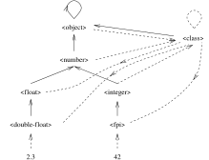
A Small Part of the EuLisp Class Hierarchy (simplified)
Dotted arrow is instance of/member of/is a; solid arrow is inherits from/subclass/extends/subset

7. Object Oriented Languages

Metaobject Protocols
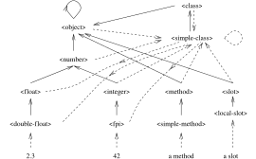
A Small Part of the EuLisp Class Hierarchy (not so simplified)
Dotted arrow is instance of or member of or is a; solid arrow is inherits from or subclass or extends

8. Object Oriented Languages

Metaobject Protocols
If we want different behaviours we can create new classes that implement those behaviours
Classes are instances of subclasses of the class <class>
Thus the class <string> is an instance of
And so strings and their methods have the “usual” behaviours, inherited from
To define new behaviours we can create a new subclass of the class <class> (or )

9. Object Oriented Languages

Metaobject Protocols
Methods: how do we find the right method to apply?
We need to find the class precedence list for an argument
So Telos provides a generic function compute-class-precedence-list
There is a predefined method on this for that does the standard thing with CPLs, as described previously
You can add a method yourself for your new class if you want to something different, e.g., reverse the order, or omit some classes, or add some strange kind of multiple inheritance, etc.

10. Object Oriented Languages

Metaobject Protocols
We need to take the CPL and choose a method (or methods) from it
The generic function compute-method-lookup-function is used for this
The standard method returns a function that simply picks the first on the list
Method combination can be implemented by specialising compute-method-lookup-function
And so on

11. Object Oriented Languages

Metaobject Protocols
Structure: how are values to be stored in an object?
Most objects are implemented as structures with the object accessors implemented as simple structure references
The generic function compute-and-ensure-slot-accessors describes how slots are accessed
The standard method does a simple structure access
So if you want slots that live on disk rather than in memory, or count the number of times they are accessed, add a method here

12. Object Oriented Languages

Metaobject Protocols
Classes: The generic functions allocate and initialize describe how objects are created
So if you want to have an object that lives outside the normal class hierarchy, or has a different structure, add methods here
And so on

13. Object Oriented Languages

Metaobject Protocols
There are standard, predefined, methods everywhere, of course, that do the “usual” things, i.e., they implement the behaviour you would expect from a normal OO language
For example, a method on initialize that fills in a newly allocated object
But if you want to change how that happens, you can

14. Object Oriented Languages

Metaobject Protocols
Metaobject protocols are very powerful and so are easy to abuse
And easy to misuse accidentally
But they do allow you to do exactly what you want in an OO system
You are not limited by the language, only your imagination

15. Object Oriented Languages

Metaobject Protocols
Exercise Investigate the Metaobject class in Java
Exercise Investigate the metaobject system in Python
Exercise Investigate Joose, the JavaScript metaobject system
Exercise Investigate Moose, the Perl metaobject system

16. Object Oriented Languages

End of OO
A note on efficiency of OO
You might think, with all this complexity, that OO languages must be very inefficient, and produce code that runs only very slowly
The good thing is that with careful design of the language and good compilers an OO language need not be any less efficient than, say, a procedural language
For example, Rust and C++ are pretty much as efficient as C

17. Object Oriented Languages

End of OO
This is because many of the complex OO mechanisms (method lookup, attribute lookup, etc.) have the potential of being statically done at compile time, so a method call can be as efficient as a function call
Perhaps the compiler is slower, but the generated code should not be
Dynamic languages can have a fair amount of runtime overhead, though
Of course, it’s easy to design and implement an OO language poorly, just as any other feature, but there are few intrinsic reasons why OO should be slow

18. Object Oriented Languages

End of OO
Object Oriented languages and OO concepts are widely used
There are a large number of ways of doing OO
From no classes and no inheritance all the way to MOPs
You need to able to make a choice!
Including choosing not to use OO

19. Object Oriented Languages

End of OO
C++ is history repeated as tragedy. Java is history repeated as farce
Scott McKay
Object-oriented programming is an exceptionally bad idea which could only have originated in California
Edsger Dijkstra
Object oriented programs are offered as alternatives to correct ones
Edsger Dijkstra

20. The End
There are many languages out there, both general purpose and specialist
We have briefly covered many aspects of language design
And there are many more factors we could talk about in making choices of language

21. The End
Or languages
Often a single project can use several languages, each suited to its part of the project
For example, using Python to manage a computation in C, while using Java to display the results graphically
And then the interoperability of languages becomes important
For example, can you easily join together code written in Java and C?
Or Java and Python?

22. The End
How does the managed (GC) nature of Java interact with the manual memory allocation in C? Or the GC in Java with the different GC in Python?
Do types in the languages match? An integer in Python is represented in a different way to an integer in Java or C
Sometimes integers and floating point numbers are represented in the same way, but what of Java’s objects and C’s structs?
Some languages specify a foreign function interface (FFI) that describes how to write code that interoperates with another language
Quite often a FFI to C, as C is very widely supported and used and is a “lowest common denominator” of languages

23. The End
Interopability is important in any moderately sized project and will affect which languages you may choose to use
But it is important to remember the non-functional issues, too
What is the programming environment? E.g., quality compilers, IDEs, debuggers
What languages are you familiar with and happy programming in?

24. The End
A lot of languages support features that are designed to help the “novice programmer”
But programmers don’t stay novice, so what features are there to help the intermediate or advanced programmers?

25. The End
And there are the more niche considerations, e.g., energy usage can be very important in certain situations, for example mobile phones, or when you are thinking about green computing
How much energy does the final program take to run?
If your program is going to run very many times, or you need to worry about battery life, then this measure is important
We touched on this briefly when talking about bytecoding with JIT and AOT and other execution approaches
Experiments show that C programs generally take the least energy to run

26. The End
The Top 10 performers:
C | 1.00
Rust | 1.03
C++ | 1.34
Ada | 1.70
Java | 1.98
Pascal | 2.14
Chapel | 2.18
Lisp | 2.27
Ocaml | 2.40
Fortran | 2.52
Relative energy uses of programs written in various languages
Python is number 26 at 75.88

27. The End
Exercise Read “Energy Efficiency across Programming Languages: How Do Energy, Time, and Memory Relate?” by Pereira et. al., SLE 2017: Proceedings of the 10th ACM SIGPLAN International Conference on Software Language Engineering, October 2017, pp. 256-267, https://doi.org/10.1145/3136014.3136031

28. The End
Do you need support for modern character sets (different languages, emoji)?
Support for Unicode is patchy in some languages, good in others
And some languages (and operating) systems use different encodings for the characters
For example, The Web mostly uses UTF-8 encodings, whereas SMS text messages use UTF-16 and Java, JavaScript and Windows are stuck using UTF-16 internally
Rust, Go and Python use UTF-8

29. The End
Exercise What does C do?
Exercise Find out what your favourite languages do

30. The End
Next, what is the support for writing documentation?
Tools like Sphinx for Python, Doxygen for C++, Godoc for Go, Rustdoc for Rust and so on
Exercise Read about “Literate programming” by Knuth
Hint Whenever you fix a bug in your code, put a comment on it!

31. The End
Exercise Which in the more helpful comment here?
// set c to 0
c = 0;
// initialize the object count
c = 0;
<+(0)->
And which of the above two kinds of comment appears most in student code?

32. The End
And working in teams
When joining a team, what languages are they already using?
What code management tools are they using?
What does your boss tell you to do?

33. The End
And so on
Picking the right language(s) can be complicated: but it will repay you well to think carefully about this

34. The End
Remember:
- Not all OO languages have classes
- Not all OO languages have polymorphism
- Not all class-based languages have inheritance
- OO languages are not necessarily slow or fast
- OO languages are not necessarily easy or hard to use
- Procedural languages are not necessarily slow or fast
- Procedural languages are not necessarily easy or hard to use
- Functional languages are not necessarily slow or fast
- Functional languages are not necessarily easy or hard to use

35. The End
- Not all bytecode compilers are fast
- Not all bytecode compilers are slow
- Not all native compilers are fast
- Not all native compilers are slow
- Not all VMs are large
- Not all VMs are compact

36. The End
Exercise Find examples of languages that confirm each of these statements (e.g., original JavaScript did not have classes)

37. The End
Exercise Consider:
- procedural, OO, etc.: flow of execution is determined by the code
- data driven: flow is determined by the data
- declarative: flow is determined by the system
- event: flow is determined by the events

38. The End
If anyone tells you that one language is better than another, you will know you are a better programmer than they are
It’s not a case that one language is better than another, more that one is better for the problem in hand
Be aware and learn the concepts, they are transferable between many languages
Pick the right tool for the job

39. The End
Exercise Add more languages to this chart:
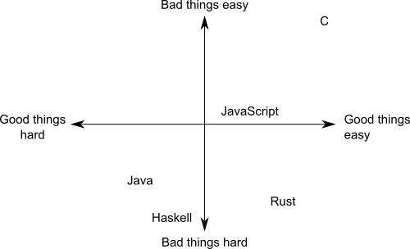
Programming good and bad, hard or easy

40. The End
Exercise For as many languages as you can, classify them as
general purpose; specific purpose; procedural; logic; declarative; imperative; functional; macro; scripting; event driven; simulation; dataflow; markup; parallel; GC; manual memory management; other memory management; typed; untyped; strongly typed; weakly typed; statically typed; dynamically typed; manifest typed; implicit typed; polymorphic typed; has overloading; has higher kinded or rank types; has dependent types; constant variables; call by value; call by reference; call by name; call by need; interpreted; compiled; byte compiled; managed code or data; unmanaged code or data; expression based; statement based; error handing support; object oriented; class centred OO; object centred OO; single inheritance; multiple inheritance; traits/mixins/interfaces; object receiver; generic functions; single dispatch; multiple dispatch; prototyping; delegation; has metaobjects; has a good development environment; has a good debugger; is easy to learn

41. The End
There are only two kinds of languages: the ones people complain about and the ones nobody uses
Bjarne Stroustrup, creator of C++
There are only two kinds of C++: the language subsets that Stroustrup insists that people should use, and the subsets that people actually use
Anon
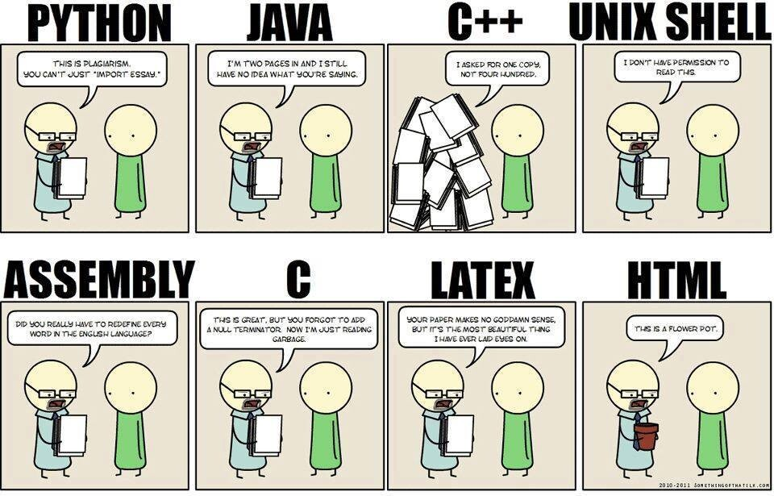
(Source unknown)

42. The End
How to shoot yourself in the foot while programming:
Pick the wrong tools
A# .NET A# (Axiom) A-0 System A+ A++ ABAP ABC ABC ALGOL ABSET ABSYS ACC Accent Ace DASL ACL2 Avicsoft ACT-III Action! ActionScript Ada Adenine Agda Agilent VEE Agora AIMMS Alef ALF ALGOL 58 ALGOL 60 ALGOL 68 ALGOL W Alice Alma-0 AmbientTalk Amiga E AMOS AMPL AngularJS Apex (Salesforce.com) APL App Inventor for Android’s visual block language AppleScript Arc ARexx Argus AspectJ Assembly language ATS Ateji PX AutoHotkey Autocoder AutoIt AutoLISP / Visual LISP Averest AWK Axum Active Server Pages ASP.NET B Babbage Bash BASIC bc BCPL BeanShell Batch (Windows/Dos) Bertrand BETA Bigwig Bistro BitC BLISS Blockly BlooP Blue Boo Boomerang Bourne shell (including bash and ksh) BREW BPEL Business Basic C C– C++ C# C/AL Caché ObjectScript C Shell Caml Cayenne CDuce Cecil Cesil Céu Ceylon CFEngine CFML Cg Ch Chapel Charity Charm Chef CHILL CHIP-8 chomski ChucK CICS Cilk Citrine CL (IBM) Claire Clarion Clean Clipper CLIPS CLIST Clojure CLU CMS-2 COBOL CobolScript Cobra CODE CoffeeScript ColdFusion COMAL Combined Programming Language (CPL) COMIT Common Intermediate Language (CIL) Common Lisp (CL) COMPASS Component Pascal Constraint Handling Rules (CHR) COMTRAN Converge Cool Coq Coral 66 Corn CorVision COWSEL CPL CPL Cryptol csh Csound CSP CUDA Curl Curry Cybil Cyclone Cython D DASL Dart DataFlex Datalog DATATRIEVE dBase dc DCL Deesel (formerly G) Delphi DinkC DIBOL Dog Draco DRAKON Dylan DYNAMO E E# EarSketch Ease Easy PL/I Easy Programming Language EASYTRIEVE PLUS ECMAScript Edinburgh IMP EGL Eiffel ELAN Elixir Elm Emacs Lisp Emerald Epigram EPL Erlang es Escher ESPOL Esterel Etoys Euclid Euler Euphoria EusLisp Robot Programming Language CMS EXEC EXEC 2 Executable UML F F# Factor Falcon Fantom FAUST FFP Fjölnir FL Flavors Flex FlooP FLOW-MATIC FOCAL FOCUS FOIL FORMAC @Formula Forth Fortran Fortress FoxBase FoxPro FP FPr Franz Lisp Frege F-Script G Game Maker Language GameMonkey Script GAMS GAP G-code Genie GDL GJ GEORGE GLSL GNU E GM Go Go! GOAL Gödel Godiva Golo GOM (Good Old Mad) Google Apps Script Gosu GOTRAN GPSS GraphTalk GRASS Groovy Hack Hadoop HAGGIS HAL/S Hamilton C shell Harbour Hartmann pipelines Haskell Haxe Hermes High Level Assembly HLSL Hop Hopscotch Hope Hugo Hume HyperTalk IBM Basic assembly language IBM HAScript IBM Informix-4GL IBM RPG ICI Icon Id IDL Idris IMP Inform INTERLISP Io Ioke IPL IPTSCRAE ISLISP ISPF ISWIM J J# J++ JADE Jako JAL Janus JASS Java JavaScript JCL JEAN Join Java JOSS Joule JOVIAL Joy JScript JScript .NET JavaFX Script Julia Jython K Kaleidoscope Karel Karel++ KEE Kixtart Klerer-May System KIF Kojo Kotlin KRC KRL KRL KRYPTON ksh L L# .NET LabVIEW Ladder Lagoona LANSA Lasso Lava LC-3 Leda Legoscript LIL LilyPond Limbo Limnor LINC Lingo LIS LISA Lisaac Lisp Lite-C Lithe Little b Logo Logtalk LotusScript LPC LSE LSL LiveScript Lua Lucid Lustre LYaPAS Lynx M2001 M4 M# Machine code MAD (Michigan Algorithm Decoder) MAD/I Magik Magma make Maple MAPPER now part of BIS MARK-IV now VISION:BUILDER Mary MASM Microsoft Assembly x86 MATH-MATIC Mathematica MATLAB Maxima (see also Macsyma) Max (Max Msp) MaxScript internal language 3D Studio Max Maya (MEL) MDL Mercury Mesa Metafont Microcode MicroScript MIIS Milk MIMIC Mirah Miranda MIVA Script ML Model 204 Modelica Modula Modula-2 Modula-3 Mohol MOO Mortran Mouse MPD Mathcad MSIL MSL MUMPS Mystic Programming Language (MPL) NASM Napier88 Neko Nemerle nesC NESL Net.Data NetLogo NetRexx NewLISP NEWP Newspeak NewtonScript NGL Nial Nice Nickle Nim NO NPL Not eXactly C (NXC) Not Quite C (NQC) NSIS Nu Numpy NWScript NXT-G o:XML Oak Oberon OBJ2 Object Lisp ObjectLOGO Object REXX Object Pascal Objective-C Objective-J Obliq OCaml occam occam-$π$ Octave OmniMark Onyx Opa Opal OpenCL OpenEdge ABL OPL OpenVera OPS5 OptimJ Orc ORCA/Modula-2 Oriel Orwell Oxygene Oz P” P# ParaSail (programming language) PARI/GP Pascal PCASTL PCF PEARL PeopleCode Perl PDL Perl 6 Pharo PHP Phrogram Pico Picolisp Pict Pike PIKT PILOT Pipelines Pizza PL-11 PL/0 PL/B PL/C PL/I PL/M PL/P PL/SQL PL360 PLANC Plankalkül Planner PLEX PLEXIL Plus POP-11 POP-2 PostScript PortablE Powerhouse PowerBuilder PowerShell PPL Processing Processing.js Prograph PROIV Prolog PROMAL Promela PROSE PROTEL ProvideX Pro*C Pure Pure Data Python Q Qalb QtScript QuakeC QPL R R++ Racket RAPID Rapira Ratfiv Ratfor rc REBOL Red Redcode REFAL Reia REXX Rlab ROOP RPG RPL RSL RTL/2 Ruby RuneScript Rust S S2 S3 S-Lang S-PLUS SA-C SabreTalk SAIL SALSA SAM76 SAS SASL Sather Sawzall SBL Scala Scheme Scilab Scratch Script.NET Sed Seed7 Self SenseTalk SequenceL SETL SIMPOL SIGNAL SiMPLE SIMSCRIPT Simula Simulink Singularity SISAL SLIP SMALL Smalltalk Small Basic SML Strongtalk Snap! SNOBOL(SPITBOL) Snowball SOL Span SPARK Speedcode SPIN SP/k SPS SQL SQR Squeak Squirrel SR S/SL Stackless Python Starlogo Strand Stata Stateflow Subtext SuperCollider SuperTalk Swift SYMPL SyncCharts SystemVerilog T TACL TACPOL TADS TAL Tcl Tea TECO TELCOMP TeX TEX TIE Timber TMG Tom TOM TouchDevelop Toi Topspeed TPU Trac TTM T-SQL Transcript TTCN Turing TUTOR TXL TypeScript Turbo C++ Ubercode UCSD Pascal Umple Unicon Uniface UNITY Unix shell UnrealScript Vala Verilog VHDL Visual Basic Visual Basic .NET Visual DataFlex Visual DialogScript Visual Fortran Visual FoxPro Visual J++ Visual J# Visual Objects Visual Prolog VSXu vvvv WATFIV WATFOR WebDNA WebQL Whiley Windows PowerShell Winbatch Wolfram Language Wyvern X++ X# X10 XBL XC xHarbour XL Xojo XOTcl XPL XPL0 XQuery XSB XSharp XSLT XPath Xtend Yorick YQL Yoix Z notation Zeno ZOPL Zsh

