Computer systems architectures
CM12002
Russell Bradford
2023/24

1. Conclusion of OS
Operating systems are still very much a current topic
We have only scratched the surface — there are many other things a real OS would have to implement
There are still lots of hard problems to solve, such as scheduling
And, as hardware changes, OSs must change, too
OSs for low-power devices (in particular mobile phones) are a huge source of research

2. Conclusion of OS
At the other end of the scale, people are still developing OSs on large supercomputers
OS virtualisation is important in the era of cloud computing
Where several users (customers) are sharing the same hardware, but each has their own, private OS running their own, private applications
Originally, OSs were the software closest to the hardware: with OS virtualisation, this is no longer necessarily true

3. Conclusion of OS
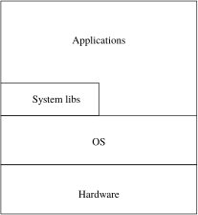
Traditional OS

4. Conclusion of OS
For example, sometimes an application only runs on a specific OS
But repeatedly rebooting a machine with a different OS every time a user wants to run a different application is not a good approach
So the solution is to have multiple, simultaneous OSs on a single machine

5. Conclusion of OS
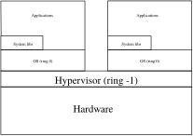
Virtualised OSs
Hypervisors appeared in IBM mainframes in the late 1960s

6. Conclusion of OS
There are several ways OS virtualisation is done

7. Conclusion of OS
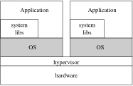
Bare metal virtualisation has a thin layer, the hypervisor, to manage the hardware, allowing each OS to see separate “virtual hardware” which they manage

8. Conclusion of OS
The OSs can be completely different, e.g., Windows and Linux, and each believe they have the whole machine
Modern X86 architectures provide a Ring -1 to support this
Examples: Xen, Hyper-V
Good for sharing the computer amongst users who have requirements for different OSs

9. Conclusion of OS
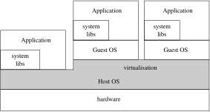
Hosted virtualisation has a normal host OS that runs virtualisation code. One or more guest OSs run on top of that
Examples: VMWare, VirtualBox, Parallels
Good for when you need sophisticated management of the guest OSs by the host OS, for example in Cloud provision

10. Conclusion of OS
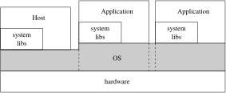
Not quite OS virtualisation, but with the same target applications is containers. The applications share the same OS, but the OS is rigidly partitioned so each container cannot see or influence what is happening in other containers (e.g., CPU limits)

11. Conclusion of OS
With containers, the applications must run on the same OS kernel, but can have different systems libraries and other software (e.g., RedHat in one and Ubuntu in another)
We might think of this as a kind of multiple user modes
Examples: Solaris containers, Docker
Good for application delivery, where an application needs a lot of specific system library support: so we deliver the systems libraries with the application!

12. Conclusion of OS
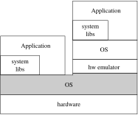
And then there are variants that do hardware virtualisation by emulating different kinds of hardware, e.g., we might have our OS running on an ARM emulation running on X86 hardware
Or on an X86 emulation on ARM hardware

13. Conclusion of OS
These emulations are a lot slower than the native hardware, but provide a flexibility to the customer
Examples: Qemu (emulates several kinds of hardware), Bochs (emulates X86)
Exercise Compare with Apple’s new Rosetta software that allows Intel code to run on Arm hardware (only user code, though)

14. Conclusion of OS
Exercise Read up on Cloud Services, Software as a Service (SaaS), Infrastructure as a Service (IaaS), Platform as a Service (PaaS), Software Appliances

15. Conclusion of OS
All of these techniques are applied in cloud computing, where users buy time on a large, remote machine
Welcome to the 1960s!

16. Conclusion of OS
Exercise On Mars, the autonomous helicopter drone Ingenuity (brought by the lander Perseverance) runs Linux on a 500Hz (not MHz!) processor. Read about this
Exercise Play with an OS you are not familiar with (Mac, Win or Lin or other) and learn the ways it does things. Write, compile and run a program
Exercise Read about the advances in persistent memory: comparable in speed to main memory, but retains data when power cycled like disk ( non-volatile). What changes would we need from an OS to deal with such a technology?

