Mathematical Sciences Worksheet



Exercise 1 (an example of how to complete this exercise can be seem at the bottom of the page)

- Write down your topic/title:

TOPIC:

- Brainstorm topic concepts and keyword alternatives:

Concept 1  AND  AND | Concept 2 | Concept 3
OR
OR

Write your topic out as a “search sentence”

EXAMPLE:
TOPIC: “options pricing and financial mathematics equations”

Concept 1  AND  AND | Concept 2 | Concept 3
options  OR  “options pricing”  investment | d  equation  formula  theory | Black-Scholes  Garman-Kohlhagen  Stochastic calculus

SENTENCE: (“options pricing” or investment) and (equation or formula) and
(Black-Scholes or Garman-Kohlhagen)
MathSciNet

MathSciNet is the electronic version of Mathematical Reviews and Current Mathematical Publications published monthly by the American Mathematical Society (AMS). It indexes material published from 1940 to date, covering all areas of pure and applied mathematics. References are included for journal articles, books, conference proceedings and audio-visual material. Critical reviews are given for most items covered, with some links to full text material.


Use the Links button to find what the library has immediate access to, see the information in exercise 2b for more detail about full text access and library links.

Connect to the Library’s Resources for Mathematical Sciences web pages at:
http://www.bath.ac.uk/library/subjects/math-sci
From the list of databases, click on the title link to MathSciNet (MSN).

Alternatively you can access MathSciNet through the library catalogue. Simply type ‘mathscinet’ in the search box on the Library’s homepage and you will get a result for the database. Then click ‘View Online’ to access it.

Exercise 2
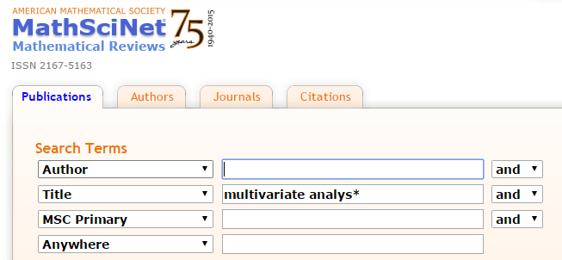
a) Search for multivariate analys* in the title field.

How many results do you get?

Does it make a significant difference if you search using anywhere?
__________________________________________________________________________________
b) On the first page of results, are you able to get full text access to any of the articles?
Each record you find has a Journal and an Article link beneath. Where the Article link is red you can click to view the full text through the library catalogue. If this link is greyed out, you will need to follow the University of Bath LINKS button at the right hand side of the record. This will connect to the library catalogue and provide a link to an electronic version if available and offer other search options, including for Print holdings.

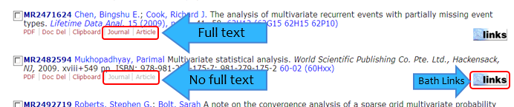

c) Search for your own topic. Try using AND, OR or NOT, or phrases and adjacency searching to see how different your results list is. Can you find relevant references for your topic? Are you able to access the full text?

Web of Science

The Web of Science is a platform which provides access to the following individual databases:
- Web of Science Core Collection (including conference proceedings)
- BIOSIS Previews
- MEDLINE

You can use the Web of Science platform to search across all the databases simultaneously or if your search is in a particular subject area, the individual databases give more detailed search options.

Exercise 3

a) Carry out a search in Web of Science on an area of your research, or use the previous search.

Think about:
- Alternative terms
- Alternative spellings
- Whether you want to use truncation (*)
- Locating the abstract
- Sorting your results
- Refining your results
- Seeing if the Library subscribes to the articles retrieved electronically or in print

Can you find relevant references for your topic? Are you able to access the full text?

b) Select a few of the references you find by clicking in the box to the left of the references then click on ‘Add to Marked List’ (at the top of the results page). Click on the words ‘marked list’ towards the top right of the screen to send these results to your email address. Fill in the necessary information following steps 1 - 3, step 1 - select records, step 2 – select content e.g. include abstract, step 3 – click on the blue envelope to send to your email address.

c) From the main search page (set to Web of Science Core Collection), click on the drop down beside the words Basic Search and select Author Search. Follow Steps 1-3 to identify records by the Vice Chancellor of the University of Bath using the following information:
Name: Glynis M. Breakwell
Research area: Psychology i.e. Social Sciences
Career links: University of Oxford (Nuffield College); University of Bristol; University of Surrey; University of Bath

How many records did you find once you have focused your search? _______

Refine your search with the keyword: psycholog* how many results do you get now? ______

Contact details for your Librarian:

Emma Stuart Edwards

Location: Library level 4, room 4.02

Phone: 01225 385809, Email: e.stuartedwards@bath.ac.uk

