Mathematics Master Class 2020 Chris Budd OBE, University of Bath

Maths Saves the Whales

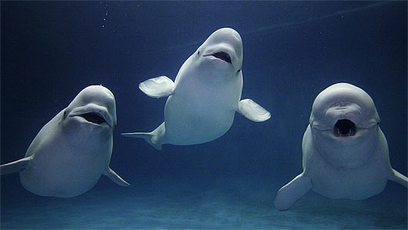

Do any questions that you like. Some involve practical work, others are more mathematical and some involve applications of Pythagoras’ theorem. I’ve indicated which are the more challenging questions.

Session One

Q1. Create a poem, story, Limerick, anagram, drama, song, art work etc about either whales, or Pythagoras or, even better, whales and Pythagoras. Try your creations out on each other.

Q2. Think of as many applications of Pythagoras’ theorem as you can.

Q3. (i) The base of a ladder of length 4m is placed 1.5m from a wall. How far up the wall can the ladder reach?

(ii) If another ladder reaches 4m up a wall and its base is 1.5m from it, how long is the ladder?

Q4. Eaglewolf, the cat, is stuck in a tall tree and needs to be saved by some firefighters. The fire engine has a 35m ladder. The closest that it can get to the tree (because there are parked cars in the way) is 12m. The cat is in the tree, 39m up. Comment on the likelihood of Eaglewolf getting saved and justify your suggestion mathematically.


The next question relates to the proof of Pythagoras’ theorem

Q3. (i) By multiplying out the brackets show that

Check by taking a = 5 and b = 12

(ii) (Harder) Draw a square with sides a + b. By dividing this square up into two smaller squares and two rectangles and working out its area in two different ways, prove the result above.

Q4. A Pythagorean triple (a,b,c) is any three whole numbers a,b,c so that

(i) Show that (a,b,c) = (3,4,5) and (a,b,c) = (5,12,13) are both Pythagorean triples

(ii) Draw the corresponding right angled triangles.

(iii) Can you find any more Pythagorean triples.

(iv) Show that if (a,b,c) is a Pythagorean triple then so is (2a,2b,2c). Check by taking (a,b,c) = (3,4,5).

(v) Challenge Show that if N is any whole number and (a,b,c) is a Pythagorean triple then so is (N*a, N*b, N*c).

Q5. Challenge (harder) We will now find a rule for generating lots of Pythagorean triples

If m and n are any two integers and

I claim that (a,b,c) is a Pythagorean triple.

- What values of m and n give (a,b,c) = (3,4,5) and (a,b,c) = (5,12,13)

- Take a few more values of m and n. Calculate a,b,c each time and show that you always get a Pythagorean triple.

- Super hard challenge Can you prove that this formula always gives you a Pythagorean triple.

HINT Square the expressions for a,b,and c and add them up
Session Two

Q1. Identify the whales on the front page and below

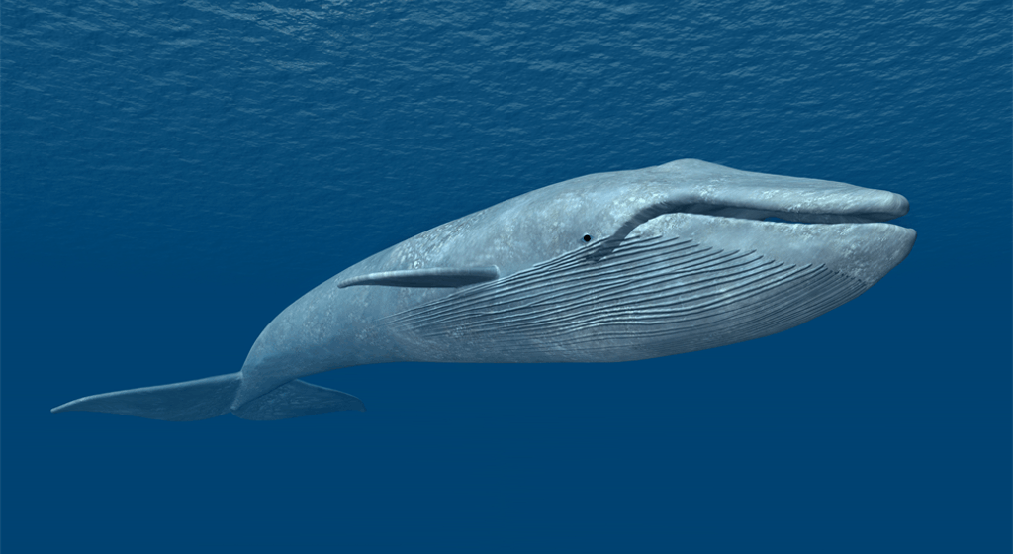
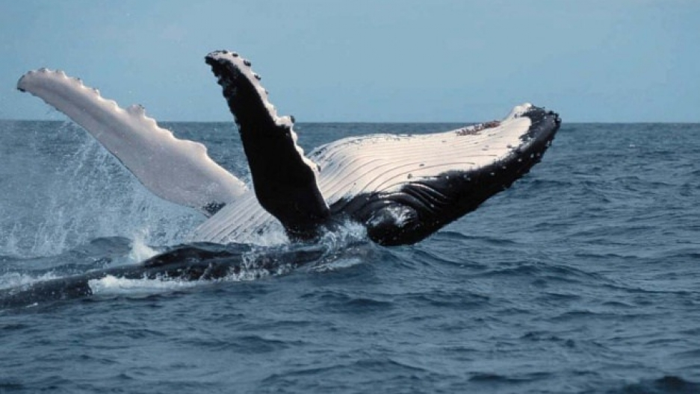

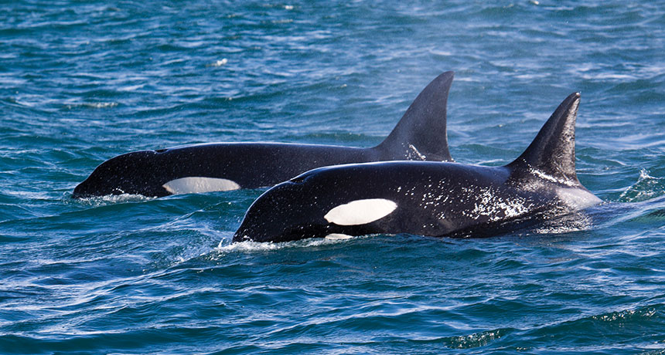
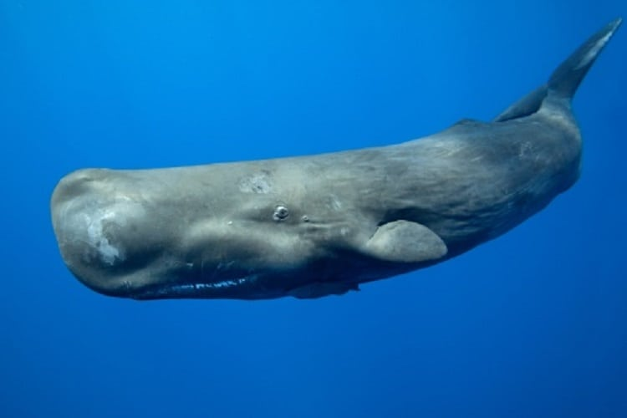

Q2 Team activity

Using the ball provided, throw it from one team member to another. Time how long this takes. By estimating the distance it went, work out how fast the ball was going.

Now do the same but bouncing the ball from the floor

Using Google, look up the speed of fastest ever tennis serve and of the fastest ever ball bowled in a cricket match. Compare this speed with your speed of throwing.

Q3 The time D it takes for a pulse to echo from the sea bed is 100ms.

The formula for the depth H of the sea is:

Taking c = 1500 metres per second find out how deep the sea is?

We need this value for the next question.

HINT: Remember that D is measured in milli-seconds

Saving the whales

Q4 This is what the ship would see when listening to the whales. A direct sound at time t_1 and another sound which is the echo at a later time t_2. There is even another echo at a later time t_3.
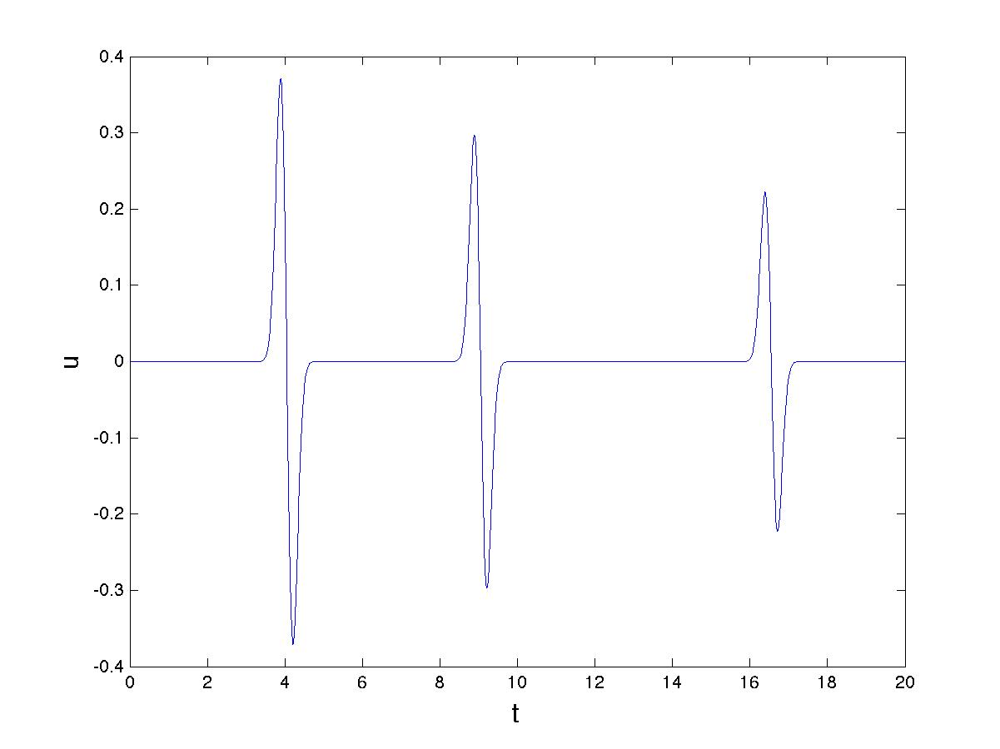

If

then the distance L to the whale is given by the formula

Using the value of H in Q.3 fill in the following table. The speed of sound in water is
C = 1500 m/s as before. For a whale to be safe it has to be at least 400m away.

 | L | Safe or not?
5 ms
10 ms
20 ms
40 ms
80 ms
100ms

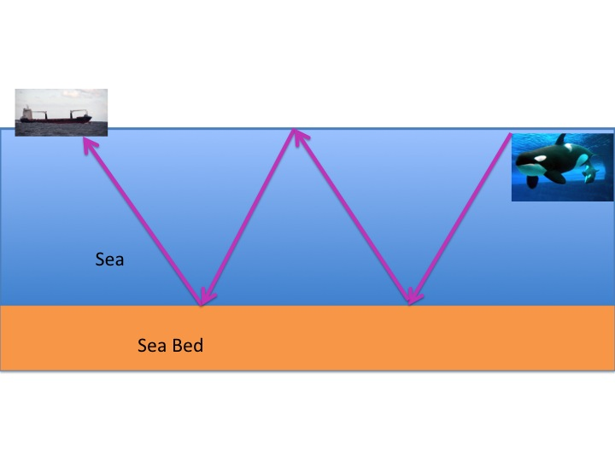
Q5. A whale sound can bounce twice from the sea-bed, and once from the surface of the sea. Here is a diagram of this situation

By using Pythagoras’ theorem, show that the time that it takes for the sound to reach the boat is given by

Q6. Very Hard Challenge: Advanced whale saving (maybe try at home/school)

By using the extra bounce we can find where the whale is without having to know the depth of the sea and using active sonar. Let

These are given by

- Show that

- Hence show that

By using this formula we can find out how far away the whale is without knowing the depth of the sea and therefore without having to use active sonar and hurting the whales.

