Chris Budd, Bath Maths Masterclass

Maths in the movies
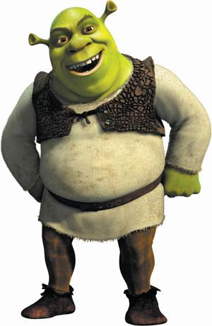

Session 1. Setting the scene

1.What is your favourite film? Does it involve maths or a mathematician?

2.Think of as many films as you can which are about maths, mathematicians, mention maths or use maths.

3. Draw pictures using triangles. See what pictures you can draw with at most 10 triangles. Colour them with stunning colours.

4. (i) Draw a curve made out of a collection of straight lines. Now use
subdivision to make it much smoother

(ii) Now do this for a polygon (a several sided figure)

(iii) Try this out on your picture in Q2.

5. If an object of size L is a distance r from the camera then the angle z we see at the camera is given by

z = L/r

this angle tells us how large the object appears to be.

By calculating the angle z, find which appears to be bigger to the camera

- You standing 2m away or a 1000m mountain 1km away?
- A coke bottle at 5cm or the mountain?

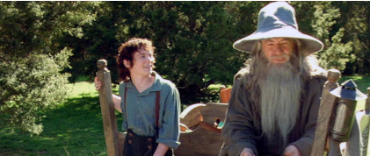

6. Ian McKellan is 1.8m tall in real life but Gandalf appears to be 2.1m tall in the movie

If Gandalf appears to stand 3m from the camera where should Ian McKellen stand so that he looks as tall as Gandalf?

HINT Work out the angle that Gandalf makes to the camera.

7. Big group project. You are the director!!

- Arrange everyone in the room in order of increasing height. With the director standing at the front of the room arrange everyone at different distances so that some of you appear to be twice as big as others. Using your phone take a picture of the result.

- Take a picture of someone standing in someone else’s hand or something equally crazy (either experiment with distances or work out the picture in advance using some geometry and Q5).

Session 2. Let’s get moving

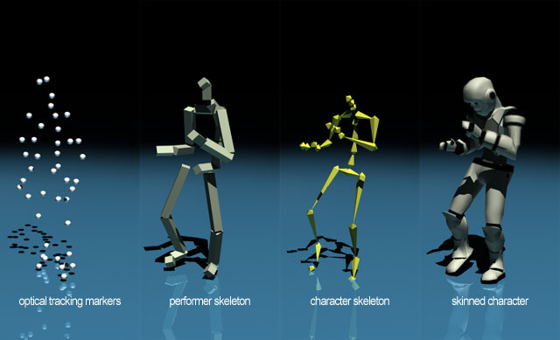

1. Nominate someone in the group to have their motion captured and make striking poses in front of everyone. Sketch a skeleton picture of their hands, feet, head and body. The wilder, the better!! Have fun!

2. Using your sketch estimate the coordinates of their hands, feet etc. (Use a ruler as necessary) for the different poses

3 (i) Take each coordinate pair in your sketch and add (1,2) to it. Plot the new coordinates and show that this has moved your figure.

(ii) Take each coordinate and multiply it by 3. Plot the figure again. What has happened

We are now going to have a go at rotating some lines. To do this we are going to take a point A with coordinates (x,y) and then move it to a new point A’ with coordinates (X,Y) using a rotation about an angle $θ$. The numbers (x,y) and (X,Y) will be related to each other by the rotation formula

4. Fill in this table of sine and cosine where all angles are in degrees. Some entries are done for you. Use your calculator to check these and do the rest.

0 | 0
20 |  | 0.939
30 | 0.5
45
60 | 0.866
90 | 1 | 0

5. Point A has coordinates (x,y) = (1,2). We can draw a line OA from (0,0) to A. Now we will use the table above and the rotation formula to find the coordinates (X,Y) of the point A’ given by rotating this line by 20,30,45,60 and 90 degrees.

(i) Work out the coordinates in the table below (some are done for you)

 | X | Y
0 | 1 | 2
20 | 0.2557 | 2.2214
30
45 | -0.707
60
90 | -2 | 0

(ii) For each case plot the line (O,A’) and see how the lines rotate.

