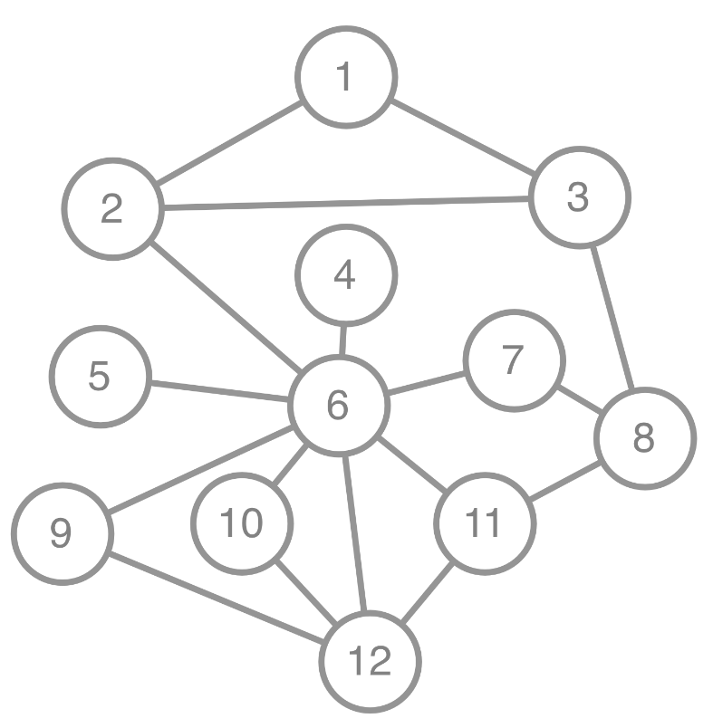
Question 1: Simulating an epidemic on a network
Method: [use this link to roll a die online https://g.co/kgs/avgvX1]
- Randomly choose a node where the infection will start [roll a 12 sided die at link above]
- At time step 1, for every susceptible node, if it has any infected neighbours:
  - Roll a die for each neighbour in turn [roll a 6 sided die at link above]
  - If the die lands on a 6, then the node has been infected by that neighbour.
  - Record the infected node in the table [column 2 “Newly infected nodes”]
- Colour in the nodes that were infected that time step
- Repeat steps 2 and 3 for all time-steps, then complete the final 2 columns.

Time | Newly infected nodes | Number new infections | Cumulative total infections
1
2
3
4
5
6
7
8
9
10

