**How to Communicate Maths**

**A guide to the Communicating Maths Course MA30241, 2020**

Chris Budd OBE, Tamsin Smith, Ben Sparks

**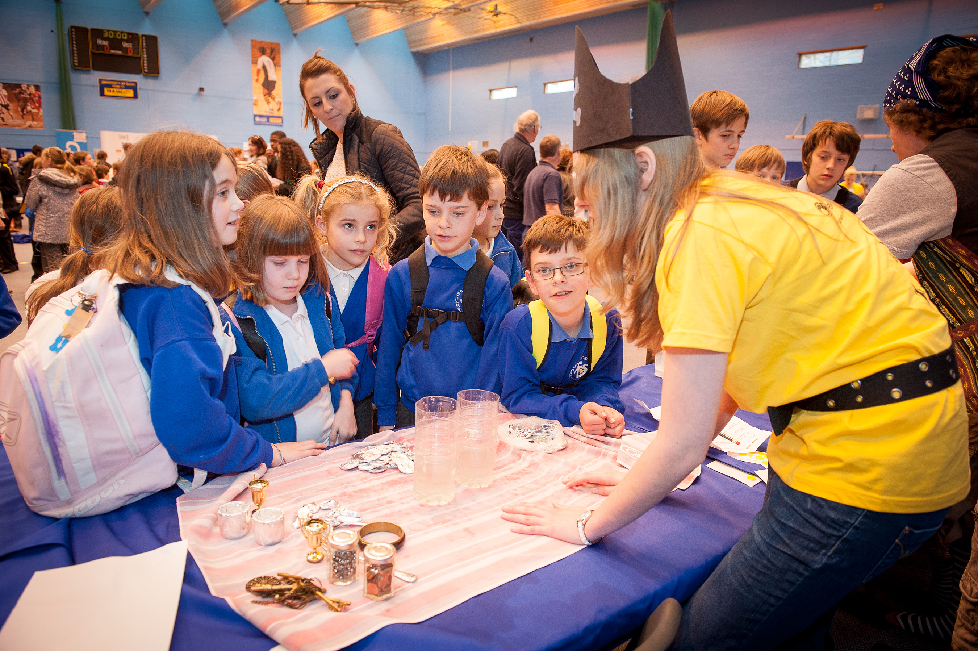**



**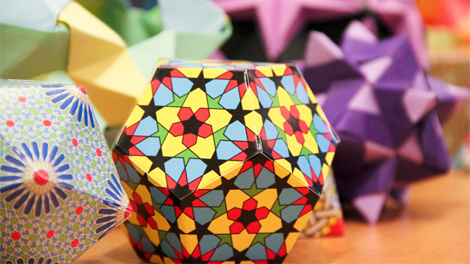**

**Contents**

1. Introduction and schedule
2. Giving a Mathematics Master Class
3. Producing a mathematics exhibition for Bath Taps Into Science
4. Options and personal pieces
5. Evaluating your work
6. Writing the report
7. References and resources

**Appendices**

A1. Dos and Don'ts for Promoting Maths to the Public

A2. How to give a great maths presentation

A3. An example of a mathematics masterclass example sheet

A4. Health & safety and risk assessment

A5. Child protection issues

**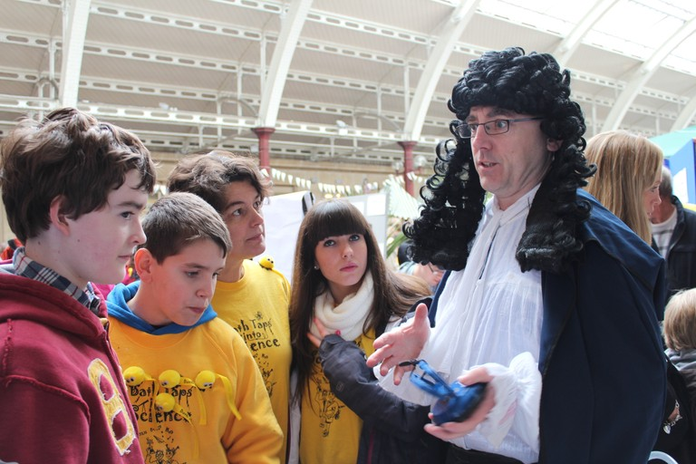**

1. **Introduction and schedule**

**Outline**

Welcome to the Communicating Maths course. This course has now been running since 2001 with about 25 students per year on the course. The purpose of the course is to give you all some training in how to communicate mathematics to a general audience, and then to give you some experience of doing this through three different activities.

Mathematics is all around us, and it plays a huge role in the modern world. For example the Internet and Google totally rely on mathematics to operate. With the increase of big data and machine learning mathematics is going to play an increasing part in the lives of everyone. Maths can also be a lot of fun, and recreational puzzles such as Sudoku, which are essentially mathematical, are very popular However, both the relevance and the recreational pleasure in doing maths, is poorly appreciated by most people. Indeed school students often cannot see the point in studying maths at all. It is therefore essential that those of us who are lucky enough to be aware of both the importance, and the fun aspects of doing maths, communicate this to a wider audience. The future of UK PLC is in our hands! This is why we are all doing this course. For a more general view on this see the article in Appendix A1.

The course is a mixture of theory, flipped classroom activity and hands on activities. The assessment will be based on a portfolio of work that you produce as a report. In Section 6 of this handbook we will explain exactly what must be put into the report to get the marks for the course. This report will describe **three activities** that you undertake during the course. These are (i) a mathematics masterclass (ii) an exhibition at the Bath Taps Into Science Festival (iii) an optional activity (usually with an external body) which can either be taken from a list of options which I will supply (for example going to the Big Bang Fair in Birmingham, taking part in a Mathematics Inspiration theatre show, going to a school, helping at a mathematics competition), or it can be a personal piece created by yourself (such as creating a web-site, producing a poster, making a mathematical game, … ).

**Time table**

We will hand out a precise timetable at the start of the course. It will have the following structure:

**January-February: Training**

In this part of the course we will look at the theory and practice of communicating mathematics to various audiences varying from young people (school students) to older audiences. There will be training workshops on the following:

1. What is expected of you in the course and in your write up.
2. Presentation and writing skills.
3. How to give a mathematics masterclass to young people.
4. How to put on a maths exhibition.
5. Evaluating your work.
6. Health and safety.
7. Child protection.

Some of the training workshops will be delivered by professional maths communicators as well as by ourselves. The training lectures will usually be delivered as two hour sessions on **Mondays 14.15-16.05 in CB 3.10**.

The training will also include a **masterclass observation** at Bath (on campus) on a Saturday morning.

During these sessions you will form teams (of typically 5 or 6) to deliver the various hands on activities. You will also select your optional activity/personal piece. You will start to plan these activities in your teams alongside your evaluation strategy.

**March – April: Flipped classroom activity**

In these sessions (on the Monday afternoons) you will give abbreviated team presentations for your masterclasses and Bath Taps exhibition **to us and to the rest of the group.** They will be expected to give you feedback on your presentations that you can then use in your planning and will help you improve the activity for when you actually deliver it the a public audience. (This is called formative evaluation).

After you have delivered your activity there will be discussion sessions for the whole group, during which we will compare how each of the activities worked as part of a summative evaluation.

**March-April: Hands on activity**

During this time you will deliver three activities: the Mathematics Masterclass, the Bath Taps exhibition and the Optional activity/Personal Piece.

WARNING As we are dealing with external organisations it is hard to be precise about time table of all of these events far in advance. Also some of the events may be quite close together. You will also have to work to tight deadlines on occasion.

**March-May: Project write up**

Once you have decided on your projects you can start to plan them. At this point you should be keeping a record of your work, which will build up into your project write up. Precise details of what is expected in this are given in Section 6. The final project should be handed in (usually as an electronic version via Moodle) **by noon on 4th May 2020 (Star Wars Day)**. (There may be cases when we will accept a later hand in date. In particular if an optional activity takes place in late April due to the requirements of the external body.)

**There will be opportunities during the training sessions for us to look at your work and to give formative feedback on how it is progressing.**

After the work is handed in it will be marked and reviewed. You will not get the final mark until your other exam marks are released.

You are expected in the course of the unit to develop and comment on three activities. In all of these you will be expected to follow the following principles.

1. **Observe** Understand what is expected of you . Do this by reading this guide, attending the training lectures and talking to myself, and others.
2. **Plan** your activity, often working in a team. The planning should include considering how you will deliver the activity and also how you will evaluate it.
3. **Deliver** your activity, possibly including a practice run before hand.
4. **Evaluate** your activity, both as you plan it, and when (and after) you deliver it.
5. **Write up** 2-4 above.

**WARNING**

The course is hard work, and it can be very intense at times! But it should not take you any more time overall than any of the rest of your units.

However, we hope, and expect, that you will get a lot out of it and that you will learn skills that will be useful to you long after you have left university.

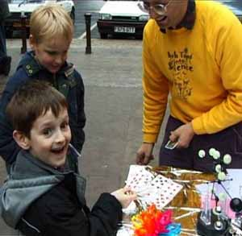

**Acknowledgements**

It is a pleasure to thank many people who have helped in producing this guide. First and foremost are all of the students who have taken the course in the past, and have given helpful (and sometimes brutally honest) feedback on it. We hope that this guide will answer (OK too late!) some of the questions that they have raised in the past. Secondly I would like to thank Rob Eastaway (director of Maths Inspiration) for reading it through and making some very helpful comments. We would also like to thank Jane White, Sam Durbin (Royal Institution), and the Bath Public Engagement Team who have contributed many of the ideas that have made this course work over many years

1. **Giving a Royal Institution mathematics masterclass.**

**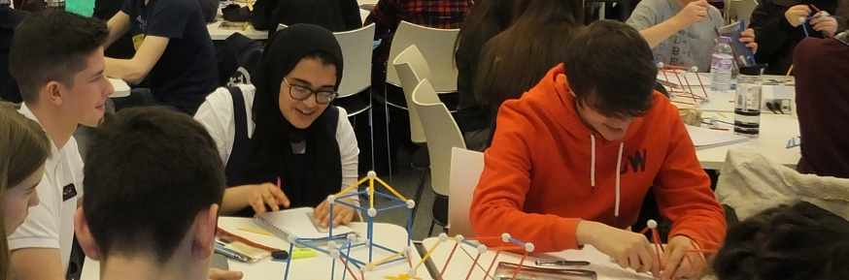**

**Background**

The Royal Institution (RI) is the oldest body in the UK working in the promotion of science to the general public. It is famous for its Christmas Lectures for Young People, which were started in the mid 19th Century by Michael Faraday. The first series of these lectures devoted to mathematics was given in 1978 By Sir Christopher Zeeman. The response to these lectures was so positive that the Royal Institution decided to work with Zeeman to launch a mathematics master class programme for school students aged about 13. These classes were originally only held at the Royal Institution, but they proved so successful that the master class network has grown to cover most of the UK. There are now also master classes for primary school children, as well as master classes in engineering and in computer science. The Royal Institution now has a permanent team to organise the master classes which includes **Samantha Durbin** who is a graduate from the Communicating Mathematics course. See <http://www.rigb.org/education/masterclasses> for more details about the master classes. The Bristol/Bath master class series was founded by Geoff Smith MBE of this department 30 years ago and is now one of the largest in the UK. It runs two series of classes. In the Autumn Term these are held at UWE, and in the Spring term at Bath. In the summer we also run a special event for all of the local master class groups at Bath. There are nearby master class groups at Exeter, South Wales, Gloucester, London and Reading, as well as groups as far away as the Orkney Isles.

Chris Budd holds the position of Professor of Mathematics at the Royal Institution and works closely with the RI to coordinate the national programme as well as giving masterclasses all over the country.

**Structure**

The secondary school masterclasses are usually for young people in Years 8 or 9 (depending on the class) . The young people are nominated by their schools, and indeed the classes are usually a partnership between schools and their local university. A typical class (but not every class) starts at 10.00am and runs till 12.30pm on a **Saturday morning.** Most young people will attend a series of 6 to 8 master classes**.** During the master class they will listen to number of short talks by the speaker(s) and they will will do a number of hands on workshops linked to the talks. A rough timetable is as follows

10-10.30 Talk one

10.30-11.00 Workshop one

11.00-11.15 Refreshments

11.15-11.45 Talk two

11.45-12.15 Workshop two

12.15-12.30 Summary talk and evaluation

12.30 Close

However there is plenty of room for flexibility around this time table. The topics for the master classes can be very diverse. The idea is to present the young people with material that will enrich their school mathematics, so that rather then directly following the school syllabus, it will show them aspects of mathematics that relate to it, but go beyond and outside it. Example of master classes might be: The mathematics of Google, Networks, Cryptography, Deep Sea Diving, Patterns and Symmetry, Mazes, Fluid Motion, Infinity, Quadratic Equations, … . `my most recent master class is on Mathematics goes to the Movies. Every class will have a main lecturer/lecturers who will be supported by a Head of House who coordinates the whole event, together with a team of tutors (usually local teachers) who are there to help with the hand on work shops. The numbers of students in the classes varies from class to class, but a figure of 100 is about right for the Bath/Bristol sessions.

**Giving a master class**

As part of the course you will work in a team of about five to deliver a master class. This can be on a subject of your own choosing, but we will give help and guidance in choosing this. The master classes take place over a number of dates in March. The initial training for this will be on the **3rd February, 2020** and will be given by Samantha Durbin. She will introduce you to the training materials produced by the Royal Institution. You will be given a choice of five different locations for the classes and you can choose your own teams. In the past we have found that the master classes given by the Communicating maths students have proved very popular with the school students.

The key things to consider with the class are as follows

* Come up with a strong theme that you think will interest the students. This should be mathematical but you can be creative in how you interpret this.
* Work out how you are going to develop this theme and how the group will deliver it. What is the key message you want to get across? How will you make this work? Is it appropriate for the age of the audience?
* Think about how the workshop sessions will operate. Construct worksheets for the two sessions.

Plan the master class in the lines above. You will then practice it in front of the whole group in the flipped classroom sessions.

Think creatively how you want to present the materials. One of the best master classes I have seen the Communicating Maths students give was a series of mathematical puzzles and games based around the Cluedo game. The school students had to work out the murderer by solving the mathematical clues. The Communicating Maths students dressed up as the various characters in the game

(Miss Scarlet, Colonel Mustard etc.). It was magnificent! Similarly, a master class on Cryptography was made much more fun when the students all dressed up as spies.

You should also devise a simple evaluation questionnaire. This can be filled in at the end of the sessions.

**Observation**

Whilst you are in the process of planning your Master Class you will have the opportunity of observing a Master Class in action. You can choose to attend any of the Saturday morning classes in Bath. These are organized by Dr. Geoff Smith MBE and are mainly given by lecturers at Bath.

Just choose a class and turn up a bit before 10am on a Saturday morning. The classes will be held in 8W. Just follow the crowd of young people.

Take notes at the class about what went well and what didn't. Also, you should get involved in the workshop sessions.

You do not need to write up the observed class in any detail, but in the planning section of your report you should describe how your planning was influenced by your observation.

**Resources**

A major source of help and advice for the Masterclass will be the Front of House for the session that you do. We will put you in touch with them as soon as possible. They will be able to advise you on the numbers and age of the young people in the class. They may also be able to review your worksheets in advance. We will do this as well.

We have included in Appendix A3 an example worksheet that I have prepared for my Maths at the Movies master class. This is divided into two sessions. There is also a quiz at the end that the students can take home with them.

The Royal Institution produce extensive training notes which I will put onto Moodle. I have also written the book *Mathematics Galore* by C. Budd and C. Sangwin, which describes eight master classes. We have a few copies of this if you want to look at them.

**Key Tips for a successful Master Class**

* Have a clear subject to base your class on.
* Give a clear set of presentations that are a mix of maths and demonstrations/applications.
* Have a set of questions for the work sheets which are a mix of easy and harder material. Show us your work sheets in advance.
* Be aware of the mathematical background of your audience. Students attending master classes are bright and motivated but they have a limited knowledge of mathematics. We can advise about the content of the Key Stage 3 syllabus.
* Work as a team and be clear about your different roles.
* Arrive early and make sure that your AV works. Make sure that you bring the right connectors for your computers if needed. Liaise with your head of house about the AV. They may well want you to send your presentation in advance,
* Contact the Master Class organiser well in advance. Check on the age and level of the young people at the class.
* Give the organizer a rough title well in advance. This will avoid duplication with other classes in the programme.

**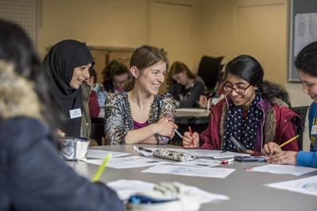**

**Master Class Check list**

Contact the organiser

Liaise with your mentor

Check on the age/level /number of the students

Confirm time and location

Check AV requirements

Book train tickets (if needed)

Produce (and practice) the talk(s)

Produce worksheet(s)

Produce evaluation sheet

1. **Presenting a mathematics exhibition at Bath Taps Into Science**

**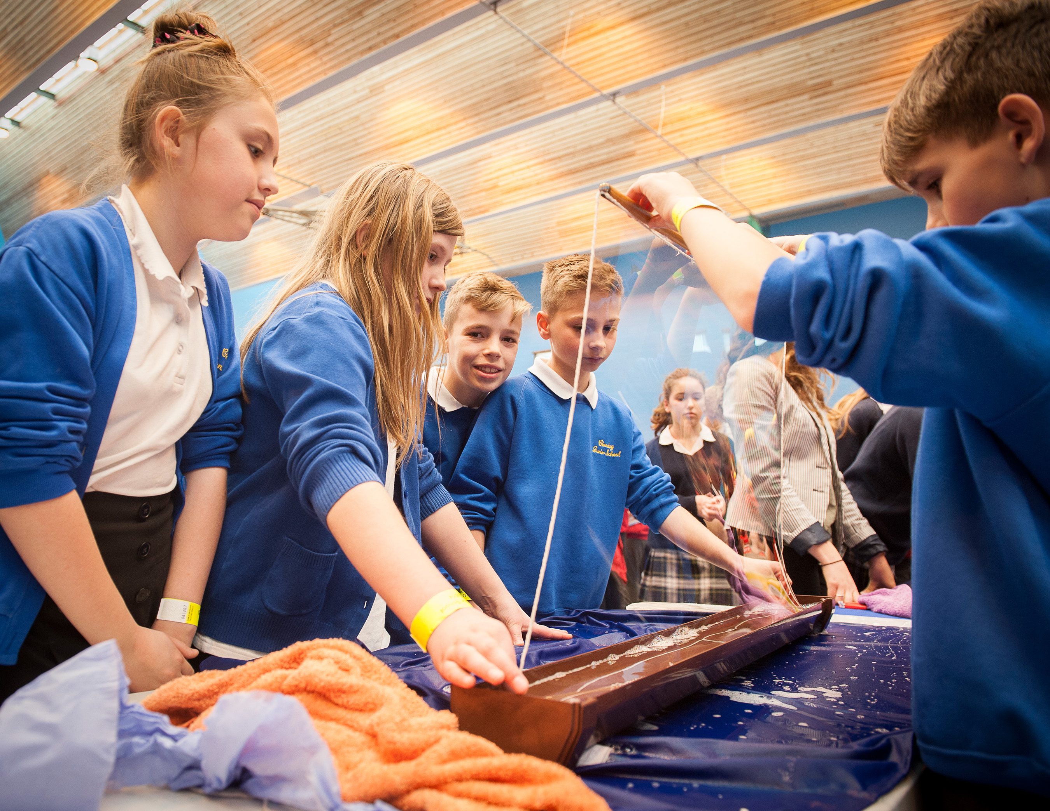**

**Background**

The Bath Taps Into Science Festival was founded in 2000 as part of decision by various organisations in Bath, including the University, to have a festival as part of National Science Week. From relatively small beginnings, it has now grown into a large festival of science with over 10 000 attendees per year. It comprises a series of linked lectures and exhibitions in various locations in Bath. These culminate in two very busy days with many hands on activities. The first of these is a schools day and is held in the Sports Village at the University. This is for local schools, and as well as putting on exhibitions for the schools we also strongly encourage the schools to put on their own exhibitions. The second day is a family day and is held in a location in Bath. In 2019 this will probably be in the Bath Forum, close to the station. This will be open to all. The festival is sponsored generously, and as a result it is not only free to participants, but we are able to offer free transport to local schools to help encourage them to come. You can find out more at

<http://bathtapsintoscience.com/> (make sure that you watch the movies!). Since its foundation Bath Taps has won a number of national awards.

\*\*\* This year the exhibition will only run on one day 13th March and will be targeted at schools. On the 14th March it is World Maths Day.

**Audience and exhibitors**

The audience for the schools event is top end primary (KS2) and bottom end secondary (KS3) students. Schools apply to come and also to exhibit. These typically come in school groups with their teachers. We place a particular emphasis on schools which are part of the widening participation strategy of encouraging young people to come to university who might not otherwise consider doing so. The family event draws on a much wider demographic, from the very young to the very old (grandchildren are our speciality). The exhibitors are a mix of staff and students (that’s you amongst others such as the chemistry PhD students) at the university, local organisations (such as the BRLSI and the Roman Baths), outside organisations (such as the British Science Association), and local (and not so local) schools. As its name suggests, the festival is a showcase for all of science and engineering, including the social sciences. Mathematics figures prominently in this. The purpose of the festival is to demonstrate to the audience that science is fun and relevant to all of their lives.

**Organisation**

Whilst I act as the overall director of Bath Taps the festival is primarily organized by the manager **Andrew Ross**, together with the University of Bath Widening Participation Team. Andrew Ross will be coming to the training event on the **10th February** and will give a presentation about Bath Taps then. He will also be concerned with the health and safety analysis of your planned exhibition and will guide you in doing a risk analysis for this. See Appendix A4 for more about health and safety aspects.

**What is expected from you?**

You will work in teams of about five (which should be different from the teams for the Master Class) to put on an exhibition for Bath Taps. This will be for half a day, and you can choose whether you want to do it on the morning or afternoon of **Friday 13th March 2019** for the Schools Day. The exhibition should be something that will capture the interest of the audience and engage them with a hands on activity. The activity should make a simple mathematical or scientific point and help your audience to learn that point. Your team should also produce a flyer which you can hand out to teachers or adults. It is common (but not compulsory) for the teams to dress up to attract the audience attention. Below we can see a group of students dressed up as pirates to give a demonstration of the principles behind buoyancy. **You will also need to register on the Bath Taps website and to complete a risk analysis form**.

****

**What sort of things can you do?**

We have had a huge variety of different topics given as exhibitions and you can use your creativity to the full in designing one. By far the best exhibits are those which are simple and make a clear point. Overly complex exhibits which require complicated equipment may not work on the day. You best visual aid (by far) is yourself. Be friendly, open and happy to answer questions. Practice a good pitch before hand and be happy to give it to any audience.

Some topics which have worked well in the past are quite mathematical including:

**Mathematical Magic**.

Below you can see a (heavily disguised) student teaching simple binary arithmetic via a magic trick. Easy and very, very effective.

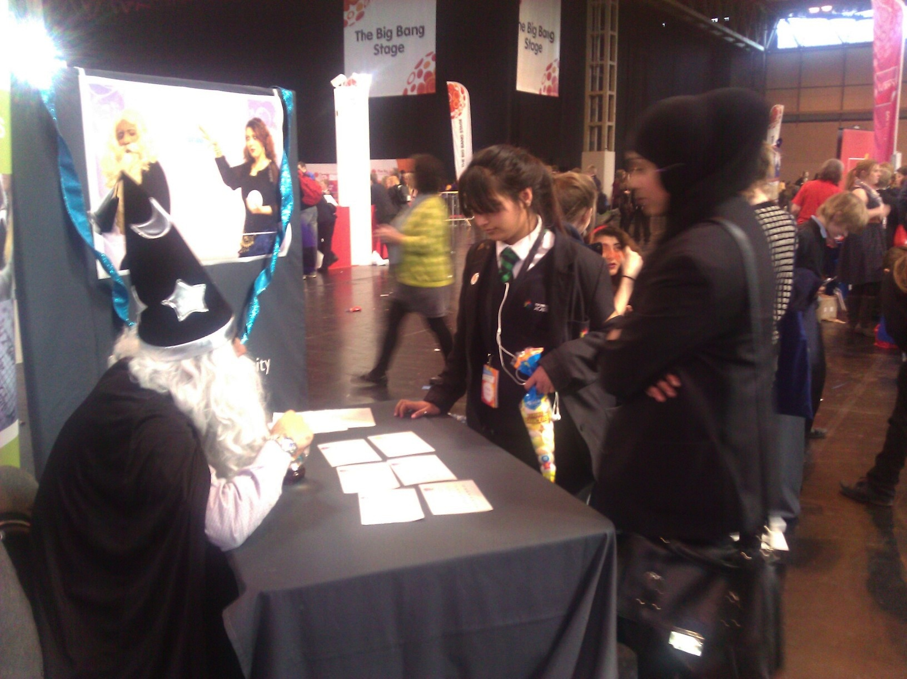

**Mobius Strips**

The team cut up a lot of bands and got the visitors to the exhibition to glue them together as Mobius Bands and then do various tricks with them. Safety scissors were used to cut them into counter intuitive patterns

**Noughts and Crosses**

Can you beat the (unbeatable) mathematician?

**Mazes**

**Knots and topology**

**Tesselations**

A number of exhibitions have demonstrated probability including

**The price is right**

**Higher and lower**

**The Monty Hall problem**

**Casino Royale**

In the latter case the students dressed up to the nines on a James Bond theme and won the BP Centurion award for the best exhibition of the year.

Other exhibits were more based in physics including

**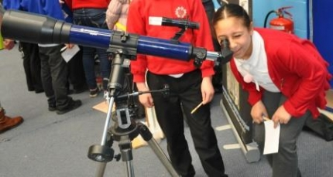Friction**

**Paper darts**

**Bouyancy**

**Pendulums**

**Gyroscopes**

**Telescopes**

And we must never forget the unforgettable **catapult**, that launched cuddly toys into an unsuspecting audience to teach them the laws of ballistics.

**This list is only meant to give you some ideas. Be creative!**

Note, that electricity is available if needed, but please be careful and tell us in advance if you need it.

**How do you put on the exhibition**

In the training session on **10th February 2020** and then the flipped classroom sessions you will have the chance to come up with your ideas, develop them, and then to run them past the rest of the group, as well as the training team and Andrew Ross and his team. This will provide you with lots of feedback and also give us a clear idea of what sort of resources may be needed. You should devise an effective evaluation strategy (See section 5). **You will also need to fill in a Risk Assessment form for your activity. See Appendix A4**.

On the day you will be provided with tables as needed and display boards. It is your responsibility to then design your props and flyers and to put on your exhibition. Lots of extra information on doing this can be found in the resources page of the Bath Taps website <http://bathtapsintoscience.com/>.

In the week before the exhibition there will be a dry run. Typically this is held just before the Bath Taps public lecture, and it will give you a chance to try out a version of your exhibition in front of small live audience. You should use this experience as part of your formative evaluation. Ask what worked and what didn’t and be prepared to learn from your mistakes.

On the day of the exhibition the timings will be

Session A Friday 10.00am – 12.30pm STV.

Session B Friday 12.30pm – 3.00pm STV

Make sure that you arrive in advance of your allocated time to set things up.

You should also bring with you the flyers that you will be handing out to the teachers and parents, and any evaluation materials that you have prepared. You have a small budget to buy props and photocopy flyers for the event.

On the day it will be fast and furious. The audience will come past in large numbers. Some will stay for a while at your exhibition, whilst others will only visit briefly. In all cases, be enthusiastic, helpful, knowledgeable and kind. Try to keep a record of the event as it unfolds, and above all enjoy yourselves.

**Key Tips for a successful Bath Taps Exhibition**

Here are some key ideas on how to put on a good exhibition

* Have a clear idea of the message that you want to communicate.
* Have a clear strategy for how you are going to do this.
* Have a clear hook that will immediately draw your audience in.
* Simplicity is good.
* Dressing up often works well.
* A smiling face works wonders.
* Test everything before hand and be prepared to evolve your exhibition if things are not working well.
* Make sure that you have everything that you need.
* Bring a repair kit (sellotape, super glue, … )
* Practice your patter to the audience.
* We are here to help. Use us!
* Make you flyer clear and informative. It is best if it is in monochrome and produce about 100.
* Have a beer (or similar) afterwards to celebrate.

**Bath Taps Check list**

* Register on the Bath Taps website
* Liaise with your mentor
* Work out what you will need in terms of poster boards/electricity/other and tell us.
* Fill in a risk assessment form
* Confirm time and location
* Produce (and practice) the exhibit
* Make sure that all your demos work
* Produce flyers
* Attend the dry run and learn from it
* Produce evaluation sheet

1. **Options and permanent pieces**

As a third activity you can do an option or produce a personal piece. I will produce a list of options. Usually these are with outside bodies who have requested that the excellent students at Bath come and work with them. You can choose any one of these. It is normal to work as part of a team when doing the option. If you prefer you can come up with your own idea, which you do by yourself as a personal piece.

**Options**

These can be very varied and change from year to year. However constant favourites include

***Secondary school*** (with Tamsin)

You work with a teacher in a Bath secondary school to deliver a lesson which is a bit out of the ordinary.

***Primary school*** (with Tamsin)

As above, but in a primary school.

***Maths Inspiration (***with Ben)

Maths Inspiration http://www.mathsinspiration.com/ is a theatre based mathematics lecture show run by Rob Eastaway, that presents maths in a very entertaining way to a mass audience of sixth formers. The presenters are usually very well known popularisers of mathematics including Matt Parker, Hannah Fry, Colin Wright, Jen Rogers, David Acheson and Paul Shepherd (Bath), Hugh Hunt and Ben Sparks (Bath).

If you choose this option you act as stewards, watch and evaluate the show, and have the chance to interview the presenters. The main event for the communicating maths course will be a show at the Theatre Royal in Bath on 12th March 2018.

***Big Bang Fair***

This is held at the NEC in Birmingham (very close to Birmingham International train station), during March. It is like Bath Taps Into Science but a lot bigger. The Communicating Maths students typically go for a day and are part of a hands on exhibition run by the Institute of Mathematics and its Applications (the IMA). They will provide a set of exhibits for you to help display, augmented by a set of hands on maths demonstration toys that we keep at Bath. I will put you in touch with John Meeson from the IMA who organizes this. If you want to see the largest hands on science show in the UK then this is well worth going to. You will also have a chance to visit the very large number of other exhibitions on display in the NEC. The sheer scale of this event is awe inspiring.

***Maths World UK (MWUK)***

This is a new venture to produce a maths museum/discover centre. You will work with a member of MWUK to design a possible exhibit for this

***MEI***

The MEI is a (local based) maths examination board. They run many activities for schools. In this option you will take part in one of these.

**Personal Piece**

In the personal piece you develop a subject of your own choosing and decide how you would like to present this to an audience. If you decide to do a personal piece you will usually do it on your own, or in a team of at most two. When designing a personal piece you should consider

* Who is your audience? For example:. School children (what age?), girls, undergraduates, New Scientist readers, tabloid readers, mums and dads etc etc.
* What medium are you going to use? For example: poster, website, blog, booklet, You Tube video, game, audio recording, newspaper article etc etc.
* What mathematical message are you trying to convey?
* How are you going to evaluate it? For example focus groups of your peers, members of your intended audience.

Topics and media for the personal piece have been very varied over the years. Foe example one year a student produced a lovely ‘Top Trumps’ card game for teaching elementary arithmetic to primary school children, another produced a booklet about the mathematical architecture in Bath, another did a mathematical quiz based on the London Underground. We have had posters encouraging girls to do maths, websites on complex numbers and (memorably) a mathematical poem. Really the only limit is your own imagination.

BUT please do NOT do anything related to the meta physical nonsense which abounds on the Internet about the Golden Ratio and/or the Fibonacci sequence. (Although a serious piece on these is quite acceptable.)

When you have decided on a personal piece let us know and we will give you some guidance on whether it is suitable, and how to execute it.

When you write up you personal piece you should address your answers to the bullet points above. You should also hand in one example of your personal piece (if it is a physical object) . If it is a website you should provide us with the URL.

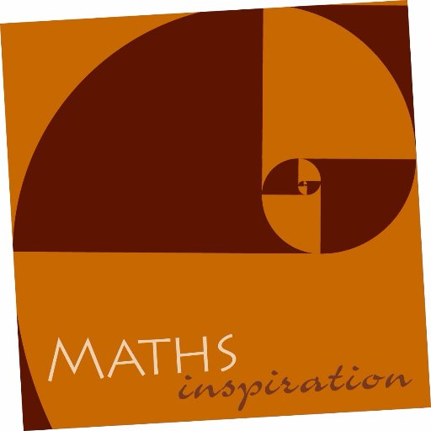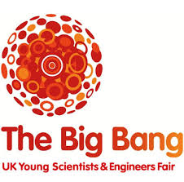

**5. Evaluating your work**

Evaluation is a very important part of any public engagement activity, and when we plan any such activity we should always have an evaluation strategy in mind. Evaluation is a process that goes through the entire lifespan of an activity, from the planning stage to the delivery and beyond if you are repeating the activity again.

There are many reasons what you might want to evaluate an activity. Here are a few

1. To see what worked and what didn’t so that you can improve the activity the next time that you deliver it.
2. So that someone else can look at your activity, and then deliver a similar one, learning from what you have done.
3. Risk assessment and health and safety
4. To look at the long term impact of your work so that you can plan strategically
5. To convince sponsors and other supporters that you have spent their money wisely and are worth investing in for the future.

In the above items 1-3 are of direct relevance to your work. Items 4-5 deeply concern me, but are of less importance to you. However there is one further reason why you want to evaluate your work.

**Evaluation counts for 40% of your overall mark!**

It is worth noting that even if everything went wrong on the day then you can still learn a lot (and get good marks) from a careful evaluation of what happened. Also bear in mind that evaluation can be a humbling experience. I have often delivered sessions which (in my opinion) were masterpieces, only to find out that I had them pitched completely wrong for my audience. You should always be willing and prepared to learn from your evaluations.

Evaluation should be both **formative** which informs your planning, and **summative** which you do at the end/delivery of your work. One of the main mechanisms for the formative evaluation will be the flipped classroom sessions*. I will be expecting you to come up with your own summative evaluation strategies*. In general summative evaluation will be a mixture of

* Quantitative data eg. Numbers, satisfaction levels, ages, genders attending.
* Qualitative data eg. Personal comments, emails, vox-pop
* Data collected at the time of the activity eg. Head counts, smiley faces
* Data collected after the activity eg. Questionnaires.
* Self evaluation eg. Keeping notes of the activity as it progresses and a diary of the event on the day.
* Evaluation by others. WARNING we will also have ‘secret evaluators’ going round Bath Taps who will visit your stall and talk to you. They will feed back their evaluation to us. You will not know who these people are. TRUST NO ONE!!!

It is important that you devise careful evaluation strategies which are appropriate to your audience and to the event. In a masterclass the audience will have to fill in a questionnaire, this will not be the case for the Bath Taps activity. If you are doing a personal piece then your formative and summative evaluation may have to be done by your fellow students. If you are going into a school then you can/should ask the teacher to help you with your evaluation.

We will be having a group debriefing session after both Bath Taps and the Masterclass to help you with your evaluation.

Present your evaluation results carefully in your write up. As you are all highly trained mathematicians we will be expecting statistical analysis complete with bar/pie charts.

* 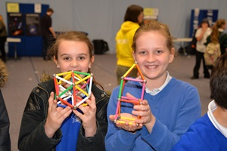

**6. Writing your report.**

The project write up should be a record of your three activities. This is a written account together with photos and worksheets. You can either hand in your work via the Moodle site or if you prefer as hard copy to the departmental office, together with a personal piece if appropriate **by noon on 4th May 2020 (remember this is Star Wars Day).** If there is a problem with meeting that date it is important that you let us know as soon as possible. The projects will be double marked. Whilst many of the activities that you describe will be the results of team work, the write up should be your work alone.

As a rough guide the write up for each of the Masterclass, Bath Taps and an option which is not a personal piece should be around ten sides (with a maximum of 15 sides) plus appendices (which can be your problem sheets, flyers etc.). The personal piece write up can be shorter as you will be judged on the piece itself as well as the write up, but the write up for the personal piece should still follow the same general format as below.

Each of the section write ups should include the following. Note that some of the activities (such as Maths Inspiration) did not include much planning, In that case we will expect you to put more into explain the context of the activity, and maybe what you learned about how the speakers planned what they delivered)

1. **Planning (30%)**

* Explain the context of the overall activity of which your work was a part. What was your audience. What background did they have.
* Description of the **aims and objectives** of your own activity and how you planned to achieve them. How were they designed around your audience?
* Explain how your team went about putting the activity together. How did you work out the different ways of doing things. What ideas did you reject.
* Explain any help that you had and how you used this.
* How did you assess the risk

1. **Delivery (20% from you +10% from an external assessor if appropriate)**

* Say what you actually did on the day. How did your team divide up the activity.
* What worked, what didn't work. What changes did you make on the day to ensure success?
* Describe how you used hand outs, worksheets etc.

1. **Evaluation (40%)**

* Carefully describe your evaluation strategy. How did you gather your data? Did you make use of any external data? Was there any other feedback on the day that you found useful?
* Carefully summarise your data, in a visual manner if possible, making use of both quantitative and qualitative data where appropriate.
* What did you learn from your evaluation?
* Explain how the evaluation allowed you to tell whether or not you met your aims and objectives as described in the planning section
* How would you improve your/the activity/personal piece if you were to do it again?

In each section we will be awarding marks for (i) clarity of exposition (ii) careful use of detail and data (iii) quality of the overall presentation. If you make use of an external resource for a substantial part of the report then you should list this in a set of references at the end of each section, though you don't need to list the web-site for every image that you might use in (say) a power point presentation.

**Length and style**

As stated earlier, you should aim at about **ten sides for each activity** (with an absolute maximum of 15 sides) plus appendices where needed (for example including the work sheets for the Master Classes and the flyers for Bath Taps). If you write much more than this then you are doing too much work and this may negatively affect your other courses.

The report should contain a write up, photos and statistical charts where needed.

**You can submit the report either via Moodle or as a hard copy.**

The reports should have your name on. It is impossible to anonymise work of this nature

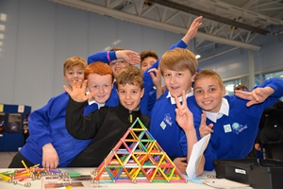

**7.Resources**

There are many resources around to help you with the course. The primary resource should be information we email to you which is also put onto Moodle. Further written resources will be placed on Moodle. You can also **read through student projects from previous years**. These are available to read at any time from the departmental office. However, you must immediately return them to the office once you have looked at them.

Some of the many **books** related to the promotion of mathematics that you might find useful are listed below. You can find many others if you look around.

D. Acheson, *1089 and all that*, Oxford

C. Budd and C. Sangwin, *Mathematics Galore*, Oxford

R. Ball, *Mathematical Recreations and Essays*, (a classic!)

R. Eastaway*,and others How long is a piece of string*, Robson

*Why do buses come in threes*, Robson

(More) *Maths for mums and dads,* Square Peg

*How to take a penalty*, Robson

M. Gardner *Further mathematical diversions*, Pelican

T. Korner, *The pleasures of counting,* Cambridge

S. Parc, *50 Visions of mathematics*, Oxford

M. Parker Things to make and do in the fourth dimension (Matt is simply a genius)

S. Singh, *Fermat’s Last Theorem,* Fourth Estate ltd.

*The Code Book,* Doubleday

*The Simpsons and their mathematical secrets,* Bloomsbury

Some excellent **websites** on promoting maths are:

<http://plus.maths.org> This is an excellent Internet magazine aimed at sixth formers and above

<http://rich.maths.org> A younger version of the above

<http://www.numberphile.com/>

THE You Tube channel for maths. Here they ‘prove’ that 1+2+3+4+ … = -1/12

<http://www.mathscareers.org.uk/> An excellent website about careers in maths

**Appendix A1. Dos and Don't’s for Promoting maths to the general public.**

(This is a write up of a joint presentation that Chris Budd gave together with Rob Eastaway at the conference *Can you talk maths in public?* in 2010)

**1. What’s it all about?**

Mathematics is all around us, it plays a vital role in much of modern technology from Google to the Internet and from space travel to the mobile phone. It is central to every school student’s education, and anyone needing to get a mortgage, buy a car, sort out their household bills or just understand the vast amount of information now thrown at them, needs to know some maths. Maths is even used to help us understand, and image, the complex networks and patterns in the brain and many of the processes of perception. However, like the air around us, the importance of mathematics is often invisible and poorly understood, and as a result many people are left unaware of the vital role that it could, and does, play in their lives. In an increasingly technology and information driven world this is potentially a major problem.

However, we have to be honest, mathematics and its relevance, is a difficult subject to communicate to the general public. It certainly doesn’t have the instant appeal of sex and violence that we find in other area (although it does have applications to these) and there is a proud cultural tradition in the UK that it is good to be bad at maths. For example when I appeared once on the One Show, both presenters were very keen to tell me that they were rubbish at maths and that it didn’t seem to have done them any harm! (I do wonder whether they would have said the same to a famous author, artist or actor). Maths is also perceived as a dry subject without any applications (this is also very untrue and I will discuss this later) and this perception does put a lot of school students (and indeed their teachers) off. Finally, and (perhaps this is what makes it especially hard to communicate), maths is a linear subject, and a lot of background knowledge, and indeed investment of time, is required of any audience to whom you might want to communicate its beauty and effectiveness. For example, one of the most important way that maths affects all of our lives is through the application of the methods of calculus. But very few people have heard of calculus, and those that have are generally scared by the very name. It also takes time and energy to communicate maths well and (to be honest), most mathematicians are not born communicators (in fact rather the opposite). However, it is a pleasure to say that there are some gifted maths communicators out there who are making a very positive impact, as well as university courses teaching maths communication skills. Indeed, the popularisation of mathematics is become and increasingly respectable and widespread activity, and I will describe some of this work in this chapter.

So why do we bother communicating maths in the first place, and what we hope to achieve when we attempt to communicate maths to any audience, whether it is a primary school class, bouncing off the walls with enthusiasm, or a bored class of teenagers on the last lesson of the afternoon? Well, the reason is that maths is insanely important to everyone’s lives whether they realise it directly (for example through trying to understand what a mortgage percentage on an APR actually means) or indirectly through the vital role that maths plays in the Internet, Google and Mobile phones to name only three technologies that rely on maths. Modern technology is an increasingly mathematical technology and unless we inspire the next generation then we will rapidly fall behind our competitors[[1]](#footnote-1). However, when communicating maths we always have to tread a narrow line between boring our audience with technicalities at one end, and watering maths down to the extent of dumbing down the message at the other. Ideally, in communicating maths we want to get the message across that maths is important, fun, beautiful, powerful, challenging, all around us and central to civilisation, to entertain and inspire our audience and to leave the audience wanting to learn more maths (and more about maths) in the future, and not to be put off it for life. Rather than dumbing down maths, public engagement should be about making mathematics come alive to people. This is certainly a tall order, but is it possible? While the answer is certainly YES, there are a number of pitfalls to trap the unwary along the way.

In this chapter I will explore some of the reasons that maths has a bad image and/or is difficult to communicate to the general public. I will then discuss some general techniques which have worked for myself, and others, in the context of communicating maths to a general audience. I will then go on to describe some initiatives which are currently under way to do this. Finally I will give some case studies of what works and what does not.

**2. What’s the problem with maths?**

Let’s be honest, we do have a problem in conveying the joy and beauty of mathematics to a lay audience, and maths has a terrible popular image. A lot of important maths is built on concepts well beyond what a general audience has studied. Also mathematical notation can be completely baffling, even for other mathematicians working in a different field. Here for example is a short quote from a paper, authored by myself, about the equations describing the (on the face of it very interesting) mathematics related to how things combust and then explode:



This quote is meaningless to any other than a highly specialist audience. Trying to talk about (say in this example) the detailed theory and processes involved in solving differential equations with an audience which (in general) doesn’t know any calculus, is a waste of everyone’s time and energy. As a result it is extremely easy to kill off even a quite knowledgeable audience when giving a maths presentation or even talking about maths in general. The same problem extends to all levels of society. Maths is perceived by the greater majority of the country as a boring, uncreative, irrelevant subject, only for (white, male) geeks. All mathematicians know this to be untrue. Maths is an extraordinarily creative subject, with mathematical ideas taking us well beyond our imagination. It is also a subject with limitless applications without which the modern world would simply not function. Not being able to do maths (or at least being numerate) costs the UK an estimated £2.4B every year according to a recent Confederation of British Industry report [2] Uniquely amongst all (abstract) subjects, mathematicians and mathematics teachers are asked to justify why their subject is useful. Not only is this unfair (why is maths asked to justify itself in this way, and not music or history), it is also ridiculous given that without maths the world would starve, we would have no mobile phones and the Internet would not function.

I have thought very hard about why the popular image and perception of maths is so different from reality and why it is culturally fine to say that you are bad at maths. There are many possible reasons for this.

**Firstly** the obvious. Maths is really hard, and not everyone can do it. Fair enough. However, so is learning a foreign language or taking a free kick, or playing a musical instrument, and none of these carry the same stigma that maths does.

**Secondly**, maths is often taught in a very abstract way at school with little emphasis on its extraordinary range of applications. This can easily turn an average student off ‘what’s the use of this miss’ is an often heard question to teachers. Don’t get me wrong, I’m all in favour of maths being taught as an abstract subject in its own right. It is the abstractness of maths that underlies its real power, and even quite young students can be captivated by the puzzles and patterns in maths. However, I am also strongly in favour of all teaching of maths being infused with examples and applications. Mathematicians often go much too far in glorifying in the ‘uselessness’ of their subject (witness the often quoted remarks by Hardy in *‘A Mathematicians Apology’* [3] see for example his concluding remark in that book[[2]](#footnote-2), which was certainly not true, given Hardy’s huge impact on many fields of science). However this is sheer nonsense. Nothing in maths is ever useless. I think that it is the duty of all mathematicians to understand, and convey, the importance and applications of the subject to as broad an audience as possible, and to teachers in particular.

**Thirdly**, we have structural problems in the way that we teach maths in English schools (less so in Scotland). Most of UK students give up maths at the age of fifteen or sixteen and never see it again. These students include future leaders in government and in the media. What makes this worse is that the huge majority of primary school teachers also fall into this category. The result is that primary level maths is taught by teachers who are often very unconfident in it themselves, and who certainly cannot challenge the brightest pupils. They certainly cannot appreciate its creative and useful aspects. (Indeed when I was at primary school in the 1960s maths lessons were actually banned by the headmistress as ‘not being creative’). Students at school are thus being put off maths far too early, and are given no incentive to take it on past GCSE. Even scientists (such as psychologists!) who need mathematics (and especially statistics) are giving up maths far too early. Perhaps most seriously of all, those in government or positions of power, may themselves have had no exposure to maths after the age of fifteen, and indeed there is a woeful lack of MPs with any form of scientific training. How are these policy makers then able to cope with the complex mathematical issues which arise (for example) in the problems associated with climate change (see the example at the end of this chapter). We urgently need to rectify this situation, and the solution is for every student to study some form of maths up to the age of 18, with different pathways for students with different abilities and motivation. (See the *report on mathematical pathways post 16* [4]and also [1]).

**Finally**, and I know that this is a soft and obvious target, but I really do blame the media. With notable (and glorious) exceptions, maths hardly ever makes it onto TV, the radio or the papers. When it does it is often either extremely wrong (such as the report in the Daily Express about the chance of getting 6 double yoked eggs in one box) or it is treated as a complete joke (the local TV reports of the huge International Conference in Industrial and Applied Mathematics at Vancouver in 2011 are a good example of this, see [www.youtube.com/watch?v=M4beANEdl4A&lr=1&feature=mhee](http://www.youtube.com/watch?v=M4beANEdl4A&lr=1&feature=mhee) ).

Sadly this type of report is the rule rather than the exception, or is given such little air time that if you blink then you miss it. Contrast this with the acres of time given to the arts or even to natural history, and the reverence that is given to a famous author when they appear on the media. Part of this can be explained by the ignorance of the reporters (again a feature of the stopping of mathematics at the age of fifteen), but nothing I feel can excuse the antagonistic way in which reporters treat both mathematicians and mathematics. I have often been faced by an interviewer who has said that they couldn’t do maths when they were at school, or they never use maths in real life, and that they have done really well. To which my answers are that they are not at school anymore and that if they can understand their mortgage or inflation or APR without maths then they are doing well. Worst of all are those journalists that ask you tough mental arithmetic questions live on air to make you look a fool (believe me your mind turns to jelly in this situation). It is clearly vital to work with the media (see later), but the media also needs to put its own house in order to undo the damage that it has done to the public’s perception of mathematics.

**3. How can maths be given a better image?**

As with all things there is no one solution to the problem of how to communicate to the broader public that maths isn’t the irrelevant and scary monster that they (and the media) often make it out to be. Many different maths presenters have adopted different (and equally successful) styles. However some techniques that I have found to have worked with many audiences (both young and old) include the following.

* Starting with an application of maths relevant to the lives of the audience, for example Google, iPods, crime fighting, music, code breaking, dancing (yes dancing). Hook them with this and then show, and develop, the maths involved (such as in the examples above, network theory matrix theory and group theory). Science presenters can often be accused of ‘dumbing down’ their subject, and it is certainly true that it is impossible to present higher level maths to a general audience for the reasons discussed above. However, a good application can often lead to many fascinating mathematical investigations
* Being proud not defensive of the subject. Maths really DOES make a difference to the world. If mathematicians can’t be proud and passionate of it then who will be? Be very positive when asked by any interviewer ‘what’s the point of that’.
* Showing the audience the surprise and wonder of mathematics. It is the counter-intuitive side of maths, often found in puzzles or ‘tricks’, that often grabs attention, and can be used to reveal some of the beauty of maths. The public loves puzzles, witness the success of Sudoku, and many of these (such as Griddler, Killer Sudoku, and problems in code breaking) have a strong mathematical basis. (Those that say that Sudoku has nothing to do with maths simply don’t understand what maths really is all about!) There are also many links between maths and magic (as we shall see later); many good magic tricks are based on theorems (such as fixed point theorems in card shuffling and number theorems in mind reading tricks). Indeed a good mathematical theorem itself has many of the aspects of a magic trick about it, in that it is amazing, surprising, remarkable, and when the proof is revealed, you become part of the magic too.
* Linking maths to real people. Many of our potential audiences think that maths either comes out of a book, or was carved in stone somewhere. Nothing could be further from the truth. One of the problems with the image of maths in the eyes of the general public is that it does not seem to connect to people. Indeed a recent letter in *Oxford Today* [6] the Oxford alumni magazine (which really should have known better!) said that the humanities were about people and that science was about things (and that as a consequence the humanities were more important). What rubbish! All maths at some point was created by a real person, often with a lot of emotional struggle involved or with argument and passion. No one who has seen Andrew Wiles overcome with emotion at the start of the BBC film *Fermat’s Last Theorem* produced by Simon Singh and described in his wonderful book [5], can fail to be moved when he describes the moment that he completed his proof. Also stories such as the life and violent death of Galois, the recent solution of the Poincare Conjecture by a brilliant, but very secretive Russian mathematician, or even the famous punch up surrounding the solution of the cubic equation or the factorisation of matrices on a computer, cannot fail to move even the most stony faced of audiences.
* Not being afraid to show your audience a real equation. Stephen Hawking famously claimed that the value of a maths book diminishes with every formula. This is partly true as my earlier example showed. There are, however, many exceptions to this. Even an audience that lacks mathematical training can appreciate the elegance of a formula that can convey big ideas so concisely. Some formulae indeed have an eternal quality that very few other aspects of human endeavour can ever achieve. Mind you, it may be a good idea to warn your audience in advance that a formula is coming so that they can brace themselves. So here goes:



Isn’t that sheer magic. You can easily spend an entire lecture, or popular article, talking about that formula alone. If I am ever asked to ‘define mathematics’ then that is my answer. Anyone who does not appreciate that formula simply has no soul! You can find out more in my article [7]. Whole (and bestselling) books [8] have been written on arguably the most important and beautiful formula of all time



which was discovered by Euler and lies behind the technology of the mobile phone and also the electricity supply industry. For more fabulous formulae see the book *17 Equations that changed the world*, by Ian Stewart [9].

* Above all, be extremely enthusiastic. If you enjoy yourself then there is a good chance that your audience will too.

**4. So, what’s going on?**

As I said earlier, we have seen a rapid increase in the amount of work being done to popularise maths. Partly this is a direct result of the realisation that we do need to justify the amount of money being spent on maths, and to increase the number of students both studying maths and also using it in their working lives. I also like to think that more people are popularising maths because it is an exciting thing to do which brings its own rewards, in much the same way that playing an instrument or acting in a play does. Maths communication activities range from high profile work with the media, to writing books and articles, running web-based activities, public lectures, engaging with schools, busking, stand up events, outreach by undergraduates and science fairs. In all these activities we are trying to reach three groups; young people, the general public and those who control the purse strings.

**The Media** As I described above, the media is a very hard nut to crack, with a lot of resistance to putting good maths in the spotlight. However, having said that we are very fortunate to have a number of high profile mathematicians currently working with the media in general and TV/radio in particular. Of these I mention in particular Hannah Fry, Ian Stewart, Simon Singh, Matt Parker, Jen Rogers, Marcus du Sautoy and Sir David Spiegelhalter, but there are many others. The recent BBC4 series by Marcus du Sautoy on the *History of maths* was a triumph and hopefully the DVD version of this will end up in many schools) and we musn’t also forget the pioneering work of Sir Christopher Zeeman and Robin Wilson. Hannah Fry, Marcus du Sautoy, Matt and Steve Humble (aka Dr Maths) also show us all how it can be done, by writing regular columns for the newspapers. It is hard to underestimate the impact of this media work, with its ability to reach millions, although it is a long way to go before maths is as popular in the media as cooking, gardening and even archaeology.

**Popular Books** Hannah Fry, Ian Stewart, Robin Wilson, Simon Singh and Marcus du Sautoy are also well known for their popular maths books and are in excellent company with John Barrow, David Acheson and Rob Eastaway, but I think the most ‘popular’ maths author by quite a wide margin is Kjartan Poskitt. If you haven’t read any of his Murderous Maths series [10] then do so. They are obstensively aimed at relatively young people and are full of cartoons, but every time I read them I learn something new. Certainly my son has learnt (and become very enthusiastic about maths) from devouring many of these books.

**The Internet** Mathematics, as a highly visual subject, is very well suited to being presented on the Internet and this gives us a very powerful tool for not only bringing maths into peoples homes but also being able to have a dialogue between them and experienced mathematicians via blog sites and social media. Of greatest note is the fabulous YouTube channel NumberPhile with regular starts such as Katie Steckles, Matt Parker, Hannah Fry and James Grime. NumberPhile presentations get millions of hits!. The (Cambridge based) Mathematics Millennium Project (the MMP) has produced a truly wonderful set of Internet resources through the NRICH and PLUS web-sites and the STIMULUS interactive project. Do have a look at these if you have time. I have personally found the PLUS web-site to be a really fantastic way of publishing popular articles which reach a very large audience. The Combined mathematical Societies (CMS) have also set up the Maths Careers web-site, http://www.mathscareers.org.uk/ showcasing the careers available to mathematicians. I musn’t also forget the very popular Cipher Challenge web-site run by the University of Southampton.

**Direct engagement with the public** There is no substitute for going into schools or engaging directly with the public. A number of mechanisms exist to link professional mathematicians to schools, of which the most prominent are the Royal Institution Mathematics Masterclasses. I am biased here, as I am the chair of maths at the Royal Institution, but the masterclasses have an enormous impact. Every week many schools in over 50 regions around the country will send young people to take part in Saturday morning masterclasses on topics as various as the maths of deep sea diving to the Fibbonacci sequence. These masterclasses are often run (and are based in) the university local to the region and are a really good way for university staff to engage with young people. Of course it is impossible to get to every school in the country and it is much more efficient to bring lots of schools to really good events. One way to do this are the LMS Popular Lectures, the Training Partnership Lectures and the *Maths Inspiration* series http://www.mathsinspiration.com/index.jsp. The latter (of which I’m proud to be a part) are run by Rob Eastaway and deliver maths lectures in a theatre setting, often with a very interactive question and answer session. A recent development has been the growth of ‘Maths Busking’, http://mathsbusking.com/ This is really busking where maths itself is the gimmick and reaches out to a new audience who would otherwise not engage with mathematics or mathematicians. Closely related are various stand up shows linked to maths such as the *Festival of the Spoken Nerd* or *Your Days are Numbered.* These link maths to comedy and reach out to a very non-traditional maths audience, appearing, for example, at the Edinburgh Fringe.

**Science fairs** are a popular way of communicating science to the public. Examples range from the huge, such as the British Science Association annual festival, the Big Bang Fair, New Scientist Live, and the Cheltenham festival of science, to smaller local activities such as Bath Taps Into Science and Maths in the Malls (Newcastle). I visit and take part in a lot of science fairs and it is fair to say that in general maths has traditionally been very much under represented. Amongst the vast number of talks/shows on biology, astronomy, archaeology and psychology you may be lucky to find one talk on maths. The problems we referred to earlier of a resistance to communicate maths in the media often seem to extend to science communicators as well. Fortunately things are improving, and the maths section of the British Science Association has in recent years been very active in ensuring that the annual festival of the BSA has a strong maths presence. Similarly the maths contribution towards the Big Bang has grown significantly, with the IMA running large events since 2011, attended by approximately 50,000 participants. Hopefully mathematics will have a similar high profile presence at future such events. Indeed 2014 marks the launch of the very first Festival of Mathematics in the UK. A related topic is the presence of mathematics exhibits in science museums. It is sad to say that the maths gallery in the Science Museum, London, is very old and is far from satisfactory as an exhibition of modern mathematics. Fortunately it is now in a process of redesign. Similarly the greater majority of exhibits in science museums around the UK have no maths in them at all. There seems to be a surprising reluctance from museum organisers to include maths in their exhibits. However, our experience of putting maths into science fairs shows that maths can be presented in an exciting and hands on way, well suited to a museum exhibition. It is certainly much cheaper to display maths than most other examples of STEM disciplines. The situation is rather better in Germany where they have the ‘Mathemtikum’ <http://www.mathematikum.de/> which contains many hands on maths exhibits as well as organising popular maths lectures, and in New York with the Museum of Maths. Plans are underway to create ‘MathsWorldUK’ which will be a UK based museum of maths.

**Maths Communicators** Finally, my favourite form of outreach are ambassador schemes in which undergraduates go into the community to talk about mathematics. They can do this for degree credit (as in the Undergraduate Ambassador Scheme <http://www.uas.ac.uk/> or the Bath ‘Maths Communicators’ scheme), for payment as in the Student Associate Scheme, or they can act as volunteers such as in the Cambridge STIMULUS programme which encourages undergraduates to work with school students through the Internet,. The undergraduates can be mainly based in schools, or can have a broader spectrum of activities. Whatever the mechanism. Student Ambassador Schemes have been identified as one of the most effective activities in terms of Widening Participation and Outreach.   They combine the enthusiasm and creative brilliance of the pool of maths undergraduates that we have in the UK, with the very need no only to communicate maths but to teach these undergraduates communication skills which will be invaluable for their subsequent careers. Everybody wins in this arrangement. The students often describe these courses as the best thing that they do in the degree, and they create a lasting legacy of resources and a lasting impression amongst the young people and general public who they work with. The recent IMA report on Maths Student ambassador Case studies <http://www.hestem.ac.uk/sites/default/files/mark_inner.pdf>

gives details on a number of these schemes.

**5. What doesn’t work**

I repeat the fact that maths can remain hard to communicate, and it is very easy to fall into a number of traps. For the sake of a balanced Chapter (and to warn the unwary) here are a few examples of these.

**Too much or too little** We have already seen an example of where too much maths in a talk can blow your audience away. It is incredibly easy to be too technical in a talk, to assume too much knowledge and to fail to define your notation. We’ve all been there, either on the giving or the receiving end. The key to what level of mathematics to include is to find out about your audience in advance. In the case of school audiences this is relatively easy – knowing the year group and whether you are talking to top or bottom sets should give you a good idea of how much maths they are likely to know. Yet too often I have seen speakers standing in front of a mixed GCSE group talking about topics like dot products and differentiation and assuming that these concepts will be familiar. It is equally dangerous to put in too little maths and to water down the mathematical content so that it becomes completely invisible, or (as is often the case) to talk only about arithmetic and to miss out maths all together. With a few notable exceptions, most producers and presenters in the media, think that any maths is too much maths and that their audience cannot be expected to cope with it at all. But this only highlights the real challenge of presenting maths in the media where time and production constraints make it very hard indeed to present a mathematical argument. In his Royal Institution Christmas Lectures in 1978, Prof Christopher Zeeman spent 12 minutes proving that the square root of 2 was irrational. It is hard to think of any mainstream prime time broadcast today where a mathematical idea could be investigated in such depth. A couple of minutes would probably be the limit, far too short a time to build a proof. Perhaps at some point in the future this will change, but for the time being, maths communicators have to accept that television is a very limited medium for dealing with many accessible mathematical ideas.

**The curse of the ‘formula’** As I have said, one of the ways of engaging audiences in maths is by relating it to everyday life and done correctly this can be very effective. This can, however, be taken too far. Taking a topic that is of general interest – romance, for example – and attempting to ‘mathematise’ it in the hope that the interest of the topic will rub off on the maths, can backfire badly. Much of the maths that gets reported in the press is like this. Although we love the use of formulae when they are relevant, the use of irrelevant formulae in a talk or an article can make maths appear trivial. For example, I was once rung up by the press just before Christmas and asked for the ‘formula for the best way to stack a fridge for the Christmas Dinner’. The correct answer to this question is that there is no such formula, and an even better answer is that if anyone was able to come up with one they would (by the process of solving the NP-hard Knapsack problem) pocket $1000 000 from the Clay Foundation. However the journalist concerned seemed disappointed with the answer. No such reluctance however got in the way of the person that came up with



Which is apparently the formula for the perfect kiss. All I can say is: whatever you do, don’t drop your brackets. For the mathematician collaborating with the press this might seem like a great opportunity to get maths into the public eye. To the journalist and the reading public, however, more often it is simply a chance to demonstrate the irrelevance of the work done by ‘boffins’. Such things are best avoided.

**6. And what does work.**

I will conclude this chapter with some examples of topics that contain higher level of maths in them than might be anticipated and communicate maths in a very effective way. More examples of case studies can be found in my article [11], or on my website <http://people.bath.ac.uk/mascjb/>, or on the Plus maths website http://plus.maths.org

**Example 1. Asperger’s Syndrome** The following appeared in a popular book which on the face of it had nothing to do with maths

*A triangle with sides that can be written in the form n2 + 1, n2 – 1 and 2n (where n > 1) is right-angled. Show by means of a counter-example that the converse is false.*

[The full proof appears later in the book]

The book in question was the *Curious incident of the dog in the night-time* by Mark Haddon[12] which is a book about Asperger’s Syndrome, written from a personal perspective. Millions of people have read this book, and many of these (who are not in any sense mathematicians) have read this part of it and have actually enjoyed, and learned something, from this. The reason this worked was twofold. First, the maths was put into the context of a human story, which made it easier for the reader to empathise with it. The second was that the author used a clever device whereby he allowed the lead character to speak for maths, while his friend spoke for the baffled unmathematical reader. As a result, Haddon (a keen mathematician) managed to sneak a lot of maths into the book without coming across as a geek himself.

**Example 2. Maths Magic** Everyone (well nearly everyone) likes the mystery and surprise that is associated with magic. To a mathematician, mathematics has the same qualities, but they are less well appreciated by the general public. One way to bring them together is to devise magic tricks based on maths. I have already alluded to some of these. The general idea is to translate some amazing mathematical theorem into a situation which everyone can appreciate and enjoy. These may involve cards, or ropes, or even mind reading. As an example, it is a well known theorem that if any number is multiplied by nine, then the sum of the digits of the answer is itself a multiple of nine. Similarly if you take any number and subtract from it the sum of its digits then you get a multiple of nine. Put like this these results sound rather boring, but in the context of a magic trick they are wonderful ambassadors for mathematics. The first leads to a lovely mind reading trick. Ask your audience to think of a whole number between 1 and 9 and then multiply it by 9. They should then sum the digits and subtract 5 from their answer. If they have a 1 they should think A, 2 think B, 3 think C etc. Now take the letter they have and think of a country beginning with that letter. Take the last letter of that country and think of an animal beginning with that letter. Now take the last letter of the animal and think of a colour beginning with that letter. Got that. Well hopefully you are now all thinking of

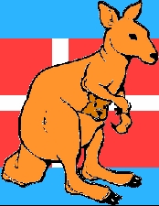

The reason that this trick works, is that from the first of the above theorems, the sum of the digits of the number that they get must be 9. Subtract 5 to give 4, and the rest is forced. This trick works nearly every time and I was delighted to once use it for a group of blind students, who loved anything to do with mental arithmetic. For a second trick, take a pack of cards and put the Joker in as card number 9. Ask a volunteer for a number between 10 and 19 and deal put that number of cards from the top. Pick this new pack up and ask for the sum of the digits of the volunteer’s number. Deal that number of cards from the top. Then turn over the next card. It will always be the Joker. This is because if you take any number between 10 and 19 and subtract the sum of the digits then you always get 9.

With a collection of magic tricks you can introduce many mathematical concepts, from primary age maths to advanced level university maths. The best was to do this, is to first show the trick, then explain the maths behind it, then get the audience to practice the trick, and then (and best of all) get them to devise new tricks using the maths that they have just learned. You never knew that maths could be so much fun!

**Example 3. How Maths Won the Battle of Britain** It may be unlikely to think of mathematicians as heroes, but without the work of teams of mathematicians the Allies would probably have lost the Second World War.Part of this story is well known. The extraordinary work of the mathematical code breakers, especially Alan Turing and Bill Tutte, at Bletchley Park has been the subject of many documentaries and books (and this is one area where the media has got it right). This has been described very well in the Code Book (also) by Simon Singh [13]. However, mathematics played an equally vital role in the Battle of Britain and beyond. One of the main problems faced by the RAF during the Battle of Britain was that of detecting the incoming bombers and in guiding the defending fighters to meet them. The procedure set up by Air Vice Marshall Dowding to do this, was to collect as much data as possible about the likely location of the aircraft from a number of sources, such as radar stations and the Royal Observer Corps, and to then pass this to the ‘Filter Room’ where it was combined to find the actual aircraft position. The Filter Room was staffed by mathematicians who’s job was to determine the location of the aircraft by using a combination of (three dimensional) trigonometry to predict their height, number and location from their previous known locations, combined with a statistical assessment of their most likely position given the less than reliable data coming from the radar stations and other sources. Once the location of the aircraft was known further trigonometry was required to guide the fighters on the correct interception path (using a flight direction often called the ‘Tizzy’ angle after the scientific civil servant Tizard). An excellent account of this and related applications of maths is given in Korner [14]. In a class room setting this makes for a fascinating and interactive workshop in which the conditions in the filter room are recreated and the students have to do the same calculations under extreme time pressure. One of the real secrets to popularising maths is to get the audience really involved in a hands on manner! (It is worth saying that the same ideas of comparing predictions with unreliable data to determine what is actually going on are used today both in Air Traffic Control, meteorology and robotics)

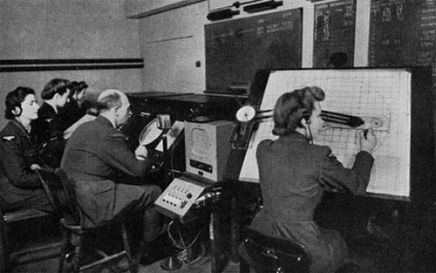

Whilst it might be thought that this is a rather ‘male oriented’ view of applied mathematics, it is well worth saying that the majority of the mathematicians employed in the filter rooms were relatively young women in the WAAF, often recruited directly from school for their mathematical abilities. In a remarkable book [15], Eileen Younghusband recounts how she had to do complex three dimensional trigonometric under extreme pressure, both in time and also knowing how many lives depended on her getting the calculations right. After the Battle of Britain she ‘graduated’ to the even harder problem of tracking the V2 rockets being fired at Brussels. When I tell this story to teenagers, they get incredibly involved and there is not a dry eye in the house. No one can ever accuse trigonometry of not being useful or interesting!

**Example 4. Weather and Climate** One of the most important challenges facing the human race is that of climate change. It is described all the time in the media and young people especially are very involved with issues related to it. The debates about climate change are very heated. From the perspective, of promoting mathematics, climate change gives a perfect example of how powerful mathematics can be brought to bear on a vitally important problem, and in particular gives presenters a chance to talk about the way that equations can not only model the world, but are used to make predictions about it. Much of the mathematical modelling process can be described and explained through the example of predicting the climate and the audience led through the basic steps of:

1. Making lots of observations of pressure, temperature, wind speed, moisture etc.

2. Writing down the (partial differential) equations, which tell you how these variables are related.

3. Solving the equations on a computer.

4. Constantly updating and checking the computer simulations with new data.

5. Assessing the reliability of the prediction.

5. Informing policy bodies about the results of the simulations.

There are plenty of mathematics and human elements to this story, starting from Euler’s derivation of the first laws of fluid motion, the work of the mathematicians Navier and Stokes on fluids or Kelvin in thermodynamics (the latter was a real character), the pioneering work of Richardson (another great character) in numerical weather forecasting, and the modern day achievements and work of climate change scientists and meteorologists. However, the real climax of talking about the climate should be the maths itself which comes across well as being an impartial factor in the debate, far removed from the hot air of the politicians. As a simple example, if T is the temperature of the Earth, e is its emmisivity (which decreases as the Carbon Dioxide levels in the atmosphere increase), a is its albedo (which decreases as the ice melts), and S is the energy from the sun (which is about 1/3 kW per metre squared on average) then



This formula can be solved using techniques taught in A level mathematics, and allows you to calculate the average temperature of the Earth. The nice thing about this formula is that unlike the formula for the perfect kiss, this one can be easily checked against actual data. From the perspective of climate science its true importance is that it clearly shows the effects on the Earth’s temperature (and therefore on the rest of the climate) of reducing the emmisivity e (by increasing the amount of Carbon Dioxide in the atmosphere) or of reducing the albedo a (by reducing the size of the ice sheets. This leads to a frightening prediction. The hotter it is the less ice we have as the ice sheets melt. As a consequence the albedo, a, decreases, so the Earth reflects less of the Sun’s radition. Our formula then predicts that the Earth will get hotter, and so more ice melts and the cycle continues. Thus we can see the possible effects of a positive feedback loop leading to the climate spiralling out of control. This is something that any audience can connect with, and leads to fierce debates! It may come as a surprise, but we have always found that audiences generally like the ‘unveiling’ of this equation, and seeing how it can be used to make predictions. A talk about mathematics can be exactly that i.e. ‘about’ mathematics. If the audience gains the impression that maths is important, and that the world really can be described in terms of mathematical equations and that a lot of mathematics has to be (and still is being done) to make sense of these equations, then the talk to a certain extent has achieved its purpose. Talks on climate change often lead to a furious email (and other) correspondence, which goes against the implicit assumption in the media that no one is really interested in a mathematical problem. At another level, climate change is exactly the sort of area where mathematicians and policy makers need to communicate with each other as clearly as possible, with each side understanding the language (and modus operandi) of the other.

**Example 5. Maths and Art** One of the aspects of mathematics which tends to put people off is that it is perceived as a dry subject, far removed from ‘creative’ subjects such as art and music. Of course this is nonsense, as maths is as creative a subject as it is possible to get (I spend my life creating new mathematics), but it is worth making very explicit the wonderful links between mathematics and art**.** (When faced with the question: Is maths an art or a science, the correct answer is simply Yes). Some of these links run very deep, for example the musical scale is the product of many centuries of mathematical thought (started by Pythagoras). The subject of origami was for many years treated simply as an art form. However, working out the folding pattern to create a three dimensional object (such as a beetle) from a single sheet of paper is fundamentally a mathematical problem. This was realised recently by Robert Lang <http://www.langorigami.com/> amongst others, and the fusion of mathematics with Origami leads to sublime artistic creations. Another area where art meets maths in a multicultural setting is in Celtic Knots and the related Sona drawings from Africa. Examples of both of these are illustrated below, with the left figure a circular Celtic Knot created by a school student, and the right a Sona design called the ‘Chased Chicken’.

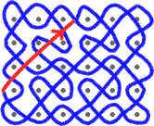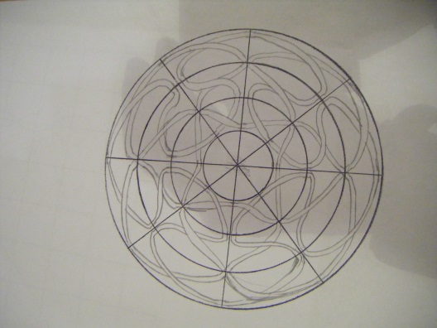

Celtic Knots are drawn on a grid according to certain rules. These rules can be translated into algebraic structures and manipulated using mathematics. By doing this, students can explore various combinations of the rules, and then turn them into patterns of art. This is an incredibly powerful experience for them as they see the direct relation between quite deep symmetry patterns in mathematics and beautiful art work. Usually when I do Celtic Art workshops I have two sessions, one where I describe the maths and then I wait for a month whilst the students work with an art department. By doing this they learn both maths and art at the same time. As I said, a very powerful experience all round. A nice spin off is the related question of investigating African Sona patterns. Mathematically these are very similar to Celtic Knots, and in fact the ideas behind them predate those of Celtic Knots. An excellent account of these patterns along with many other examples of the fusion of African mathematics and art, is given in Gerdes [16]. Doing a workshop on Celtic Knots and Sona patterns, demonstrates the fact that maths is not a creation of the Western World, but is a truly international and multi-cultural activity.

**7. And finally**

We hope that we have demonstrated in this section that although maths is hard and has a terrible public image, it is a subject that can be presented in a very engaging and hands on way to the general public. Indeed it can be used to bring many ideas together from art to engineering and from music to multi-culturalism. By doing so, everyone can both enjoy, and see the relevance, of maths. There is still a long way to go before maths has the same popularity (and image) on the media as (say) cooking or gardening (or even astronomy or archaeology), but significant progress is being made (as mathematicians say it ‘has a positive gradient’) and I am very optimistic that in ten years time, maths will have a very much better public image than it does at the present.

**8. References**

[1] Vorderman C., Porkess, R., Budd C., Dunne R and Hart P. (2011), *A world class mathematics education for all our young people,*

[http://www.conservatives.com/News/News\_stories/2011/08/~/media/Files/Downloadable%20Files/Vorderman%20maths%20report.ashx](http://www.conservatives.com/News/News_stories/2011/08/%7E/media/Files/Downloadable%20Files/Vorderman%20maths%20report.ashx" \t "_blank)

[2] CBI Report, (2009), *Making it all add up.*

[3] Hardy, G.H., (1940), *A mathematicians apology*,Cambridge University Press.

[4] ACME Report (2011), *Mathematical needs in the workplace and in higher education.*

[5] Singh S, (1997), *Fermat’s last theorem*, Fourth Estate Ltd.

[6] Oxford Today http://www.oxfordtoday.ox.ac.uk/

[7] Budd C.J., (2013), *How to add up quickly,* Plus Maths Magasine, http://plus.maths.org/content/how-add-quickly

[8] Nahin P.J., (2006), *Dr Euler’s Fabulous Formula,* Princeton University Press.

[9] Stewart I., (2012), *Seventeen equations that changed the world*, Profile Books.

[10] Poskitt K., *Murderous Maths,* Scholastic, http://www.murderousmaths.co.uk/BOOKS/books.htm

[11] Budd C. J. and Eastaway R., (2010) *How much maths is too much maths*. Maths Today (The journal of the IMA), October 2010.

[12] Haddon M., (2004),*The curious incident of the dog in the night time,* Vintage.

[13] Singh S, (1999), *The Code Book,* Doubleday.

[14] Korner T.W., (1996), *The pleasures of counting,* Cambridge University Press.

[15] Younghusband E., (2011), *One woman’s war,* Candy Jar Books.

[16] Gerdes P, (1999), *Geometry from Africa,* The Mathematical Association of America.

**Appendix A2 How to give a great maths presentation**

**General thoughts**

Presenting maths isn’t easy. How I envy my colleagues in history who can thrill their audience with tales of sex and violence and get paid for doing so. Instead, we might be faced with motivating a group of bored teenagers on the delights of the quadratic equation. However, with care and thought it is possible to give a great maths presentation which both entertains and informs your audience, and does not send them to sleep or make them walk out. Whilst a lot has been written about giving presentations there is really only one Golden Rule for giving a good one.

**You won't go far wrong if you imagine yourself sitting in the audience, and you give a presentation that you would really want to hear.**

I have put some examples of presentations onto Moodle for you to look at. These include a Master class talk on *Maths in the Movies* (complete with movie clips) and a talk to a general audience on *What have mathematicians done for us?* These are meant to give you some ideas. Have a look at these and see ways that you can improve on them!

We don’t have an ABC for giving a good talk. But we do have an **ABCDEF.** Here it is

**Audience** Love your audience. You really want to talk to them and they really want to hear you. Be aware of the background and motivation of the audience in front of you and adjust your presentation to suit. Talk to your audience, not at them. Above all, ensure that your audience feels that they are involved with your presentation. A good way to do this is to ask your audience a question and to get them to discuss it with each other before offering answers to you. Our job is to inspire our audience and to bring them up from their base of knowledge and understanding to something new and exciting. (This is NOT achieved, nor need it be, by dumbing down material.)

**Belief** If you don’t believe in the value of maths then no one else will. Remember that maths is the greatest subject in the world (or at least it should be for the duration of your presentation).

**Content** Have a clear idea of the message(s) that you want to convey, and tell the message in a clear way from start to finish. Don’t try to put in too much. Many talks fail by having far too much content. Less is more! You should aim to have as few words on a slide as possible. Maths talks can fail in particular by being far too technical and losing the audience 30 seconds into the talk. Counteract this by having a mix of light and more technical content. Don’t use heavy notation, and make sure that you define any notation before you use it.

**Delivery** Speak clearly and maintain eye contactwith your audience. You will be able to tell from the audience reaction whether you are connecting with them or not. Make sure that your audience can both see and hear you. Don't put too much information on each slide. Make good use of colour and pictures. It is often good to stop talking to your audience at some point (or points) in the presentation and to instead ask the audience a question or give them something to do. This is especially important when working with young people. Engage your audience! Humour works well. Have a strong start and a strong finish.

**Enthusiasm** Show unlimited enthusiasm. The audience will pay far more attention to the talk if you are clearly excited in it yourself.

**Finish on time** No one will forgive you if you go over time. The best way to give an hour long talk is to prepare a 40 minute one, and to take it slowly. If time is running out have a final, stunning, slide which you can skip to and will give your talk a big finish! (Always have a big finish!)

**WARNING** Many lecture rooms do not have a clock in them. This is not good and can make timing a talk hard. It is a good idea to bring your own clock along which you can see easily.

**Visual aids and AV**

Lots and lots has been written on the use of visual aids in a talk. Most of it, in my opinion goes much too far and you get the impression that all that matters in a talk is the visuals. The key thing to remember instead is that visual aids they are just that, **aids**. They should add to the message rather than become to the message.

By far your best visual aid is your face. Make sure that you show it to your audience. It has the advantage that it can't run out of batteries, nor can you leave it on the bus. Don’t forget to use the rest of your body too, and in certain cases it is legitimate to put on a costume.

Having said that, most presentations that you will give will use Powerpoint, Beamer or similar. If you do this, make sure that you use a version which produces good, clear mathematics. (Make your formulae nice and big!) Pictures and graphs are always good, and are easy to include. Movies can be very powerful, and you should certainly consider using them. But bear in mind that they may not work on the day with a different AV set up from the one that you are used to. So don’t base your whole presentation around them. My personal rule is to never have more slides than minutes in your talk. Aim for fewer slides rather than more.

When you go to give your presentation, arrive early to make sure that the AV all works. Make sure that you take all of the right connectors with you. It is well worth having your presentation on a USB stick as well. The organizer of the event may ask you to email the presentation to them in advance. If so then make sure when you arrive that it is correctly loaded and plays correctly.

Sometimes (rarely!) the AV all goes wrong. I once had a data projector explode on me one slide into my presentation. In cases like this the show must go on. You can still get a long way with talking to your audience. In my case I improvised a talk around the things I found in my pocket.

It is often a good idea to supplement a computer presentation with **real** visual aids. My double pendulum has travelled the world with me.

Another great ‘visual aid’ is to get members of the audience up on stage with you. This can be very effective, but needs careful planning to work well.

**Questions**

These are good, and you should not be afraid of answering them.

Some questions may be less than serious such as

What is your favourite number? (Good to have an answer for that one. Mine is 31.)

What is 1425 \* 19234? (do not even attempt to answer that one.)

Alternatively there may be serious questions about the content of your presentation. Excellent! This shows that the audience have listened and engaged with the talk.

It is also quite possible, if you are at a school, or even at a Master Class, that you may get questions about your experiences at university. These are well worth answering and your answers will make a big impact on the young people.

My advice with all questions is to use the **ABC rule**

**Acknowledge** the question. The questioner has a right to ask the question. Try to understand why they have asked it.

**Bridge** from the question to the content of your presentation

**Connect** from your question to the question

It is perfectly OK to say that you don’t know the answer to a question.

Prof Cedric Villani (look him up) who as well as being a mathematical super star (he has a Fields Medal) is also the public face of mathematics in France. He says that in a TV interview he has three ‘answers’ up his sleeve, which he uses whenever appropriate.

**Examples**

It is a good idea to look at some examples of good presentations. If you want to see good maths presenters then either Hannah Fry or Matt Parker are excellent and you can find them on You Tube. We will also have our very own Ben Sparks give you a demonstration presentation during the course. Personally I have always found inspiration in how to connect with an audience from watching great stand up comedians such as Bill Baily, Billy Connolly or Miranda Hart. Watch these and enjoy.

**Before the presentation**

Contact the event organizer. Find out (i) the AV available (ii) the room layout (iii) the back ground and expectations of the audience (iv) the length of the talk. Make sure that you know the time, date and exact location of the event.Practice your presentations before hand, if possible in front of an audience. We will give you a chance to practice part of your presentations during the flipped classroom sessions.

**And finally**

Don't forget to thank your audience and the organisers when you have finished.

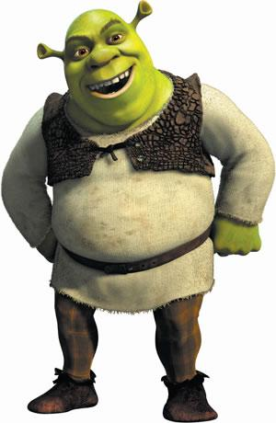

**Appendix A3. An Example Maths Masterclass Worksheet**

**Maths in the movies**

**Session 1. Setting the scene**

**1**.What is your favourite film? Does it involve maths or a mathematician?

**2**.Think of as many films as you can which are about maths, mathematicians, mention maths or use maths.

**3**. Draw pictures using triangles. See what pictures you can draw with at most 10 triangles. Colour them with stunning colours.

**4**. (i) Draw a curve made out of a collection of straight lines. Now use subdivision to make it much smoother

(ii) Now do this for a polygon (a several sided figure)

(iii) Try this out on your picture in Q2.

**5**. If an object of size L is a distance r from the camera then the effective size z of the object that we see at the camera is given by

z = L/r.

This tells us how large the object **appears** to be in the movie.

By calculating the value of z in each case, find which *appears* to be bigger to the camera

1. You standing 2m away or a 1000m mountain 1km away?
2. A coke bottle at 5cm or the mountain?

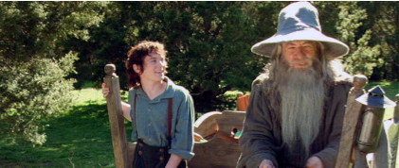

**6.** ***Ian McKellan*** is 1.8m tall in real life but ***Gandalf*** appears to be 2.1m tall in the movie

If Gandalf appears to stand 3m from the camera where should Ian McKellen stand so that he looks as tall as Gandalf?

**HINT** Work out the angle that Gandalf makes to the camera.

**7. Big group project. You are the director!!**

1. Arrange everyone in the room in order of increasing height. With the director standing at the front of the room arrange everyone at different distances so that some of you appear to be twice as big as others. **Using your phone** take a picture of the result.
2. **Take a picture** of someone standing in someone else’s hand or something equally crazy (either experiment with distances or work out the picture in advance using some geometry and Q5).

**Session 2. Let’s get moving**

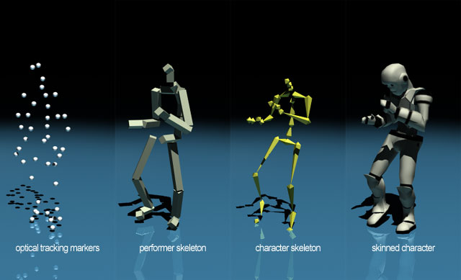

**1.** Nominate someone in the group to have their motion captured and **make striking poses in front of everyone**. Sketch a skeleton picture of their hands, feet, head and body. **The wilder, the better!!** Have fun!

**2.** Using your sketch estimate the coordinates of their hands, feet etc. (Use a ruler as necessary) for the different poses

**3** (i) Take each coordinate pair in your sketch and add (1,2) to it. Plot the new coordinates and show that this has moved your figure.

(ii) Take each coordinate and multiply it by 3. Plot the figure again. What has happened.

We are now going to have a go at **rotating** some lines. To do this we are going to take a point A with coordinates (x,y) and then move it to a new point A’ with coordinates (X,Y) using a rotation about an angle $θ$. The numbers (x,y) and (X,Y) will be related to each other by the **rotation formula**



**4.** Fill in this table of sine and cosine **where all angles are in degrees**. Some entries are done for you. Use your calculator to check these and do the rest.

|  |  |  |
| --- | --- | --- |
|  |  |  |
| 0 | 0 |  |
| 20 |  | 0.939 |
| 30 | 0.5 |  |
| 45 |  |  |
| 60 | 0.866 |  |
| 90 | 1 | 0 |

**5.** Point A has coordinates (x,y) = (1,2). We can draw a line OA from (0,0) to A. Now we will use the table above and the rotation formula to find the coordinates (X,Y) of the point A’ given by rotating this line by 20,30,45,60 and 90 degrees.

(i) Work out the coordinates in the table below (some are done for you)

|  |  |  |
| --- | --- | --- |
|  | X | Y |
| 0 | 1 | 2 |
| 20 | 0.2557 | 2.2214 |
| 30 |  |  |
| 45 | -0.707 |  |
| 60 |  |  |
| 90 | -2 | 0 |

(ii) For each case plot the line (O,A’) and see how the lines rotate.

**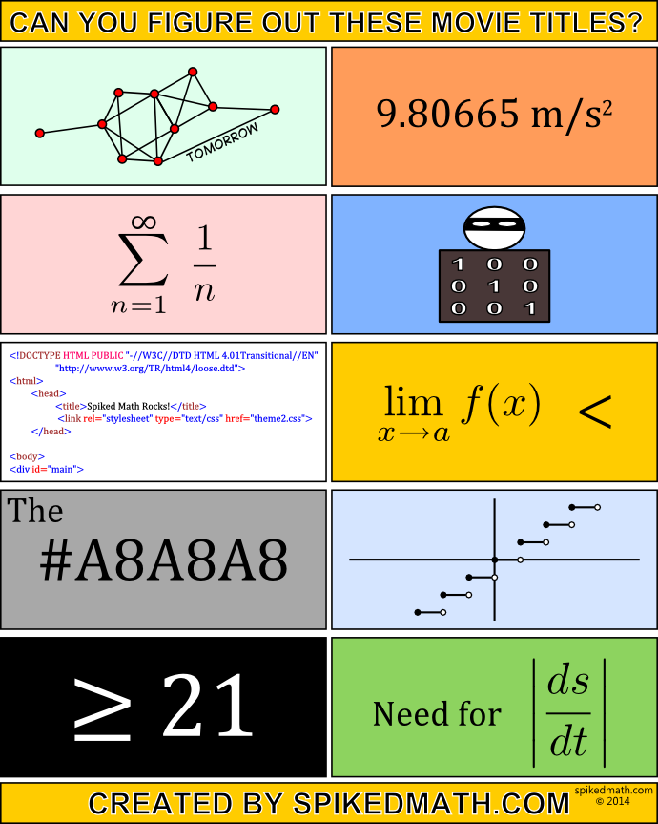**

**Appendix A4. Health & Safety and Risk Assessment.**

We take health and safety VERY seriously. It is particularly important for the Bath Taps into Science Festival where some of the activities are potentially dangerous. There is also always the danger of a trip hazard when a running child meets a water spillage. Electricity can also be a hazard. When you design your exhibits keep safety in mind, but don't let this cramp your style. Below is a risk assessment document that we will ask you to fill in as part of the planning for Bath Taps.

|  |  |  |  |  |  |  |  |
| --- | --- | --- | --- | --- | --- | --- | --- |
| **Please use the table below to judge whether an action or activity is low,**  **medium or high risk** | | | | | | | |
|  |  |  |  |  |  |  |  |

|  |  |  |  |  |  |  |  |  |  |
| --- | --- | --- | --- | --- | --- | --- | --- | --- | --- |
| After you have completed all of your actions and activites please record  the overall rating of the activity. | | | | | | | | |  |
| This will be based on the highest rating of your activites  i.e. if you have one high risk activity then the overall rating will be high. | | | | | | | | | |
|  |  |  |  |  |  |  |  |  |  |
| Once you have completed this form please return it  to Andrew Ross at [a.j.ross@bath.ac.uk](mailto:a.j.ross@bath.ac.uk). | | | | | | | |  |  |
| Please ensure this is done at least ONE WEEK before the activities.  http://2.bp.blogspot.com/-xSHY5tsTvvY/Tzqi_kSorfI/AAAAAAAABDo/cR71Da7qCQY/s1600/ProbabilityAndImpactMatrix.png | | | | | |  |  |  |  |
|  |  |  |  |  |  |  |  |  |  |

**Appendix A5. Child Protection. READ THIS WITH CARE**

Many of the activities that you will be doing will bring you into direct contact with young people. In nearly all of the activities we expect this to be **short term** and **under supervision**. As such a formal DBS is not required for such activity, although it is possible that a school might insist on a DBS in some cases. However, to make sure that all goes well it is important that you observe various guidelines when working with young people. Avoid putting yourself into any situation where an accusation could be made against you. Prevention is far, far, better than cure! We expect (and get) a high standard of behavior from the Communicating Maths students. If you have ANY reason that you think that child protection issues may be problematic to you then you MUST inform me immediately.

1. Try to make sure that you are never alone with a young person. As you are working in groups this will nearly always be the case. Be cautious of places, such as lavatories, where you might unavoidably be in a position where you are alone with a young person.
2. Avoid unnecessary physical contact with a young person. Sometimes this is necessary in some of the hands on activities, but keep this to a minimum.
3. Do not raise your voice, discipline, or otherwise make a young person feel uncomfortable. Show endless patience, kindness and understanding.
4. If you come across a young person in distress (maybe they have lost a parent) then summon help from the event organisers.
5. Make sure that your activities are as safe as possible. Expect the unexpected. Is your activity really child proof?
6. Avoid giving out sweets, or anything which might cause an allergic reaction.
7. If an accident occurs (for example a running child slips and hurts themselves) then seek help from the event organisers/teachers/parents. There will also be a first aid team available. Make a record of what has happened and get witnesses where possible. Show this to us as soon as possible.
8. It is permitted to take photos of the young people during the schools event, unless they have a badge which says otherwise. During the family event you should ask permission from the parents. You can put these photos into your report, but do not put them onto any website.
9. **Do not** email any young person after the event or maintain any other form of contact with them.
10. In the unusual situation of a child reporting an abuse related or other situation to you, you should note down what they say (giving date and time and as much information as possible) and inform one of us immediately.

1. A lot of these issues were explored in the ‘Vorderman report’ *A world class mathematics education for all our young people*, 2011, [1] of which I was a co-author [↑](#footnote-ref-1)
2. I have never done anything “useful.” No discovery of mine has made, or is likely to make, directly or indirectly, for good or ill, the least difference to the amenity of the world.... [↑](#footnote-ref-2)