Maths Masterclass March 2023

The University of Bath

How to amaze your friends

Session One

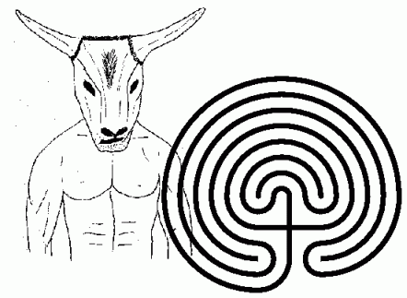

1. How many real-life mazes and labyrinths are you aware of?
2. Try solving some of the mazes supplied or make up a fantastic maze and challenge a friend to solve it.
3. Draw a Cretan Labyrinth from a seed. (You should use some paper to do this, but next time you are on a beach, try drawing it in the sand.)
4. Draw a labyrinth starting from each of the following seeds (or make up your own seed and use that to draw a Labyrinth).
5. Suppose that a Cretan Labyrinth is 5cm in diameter. How long is the route from the beginning to the centre?

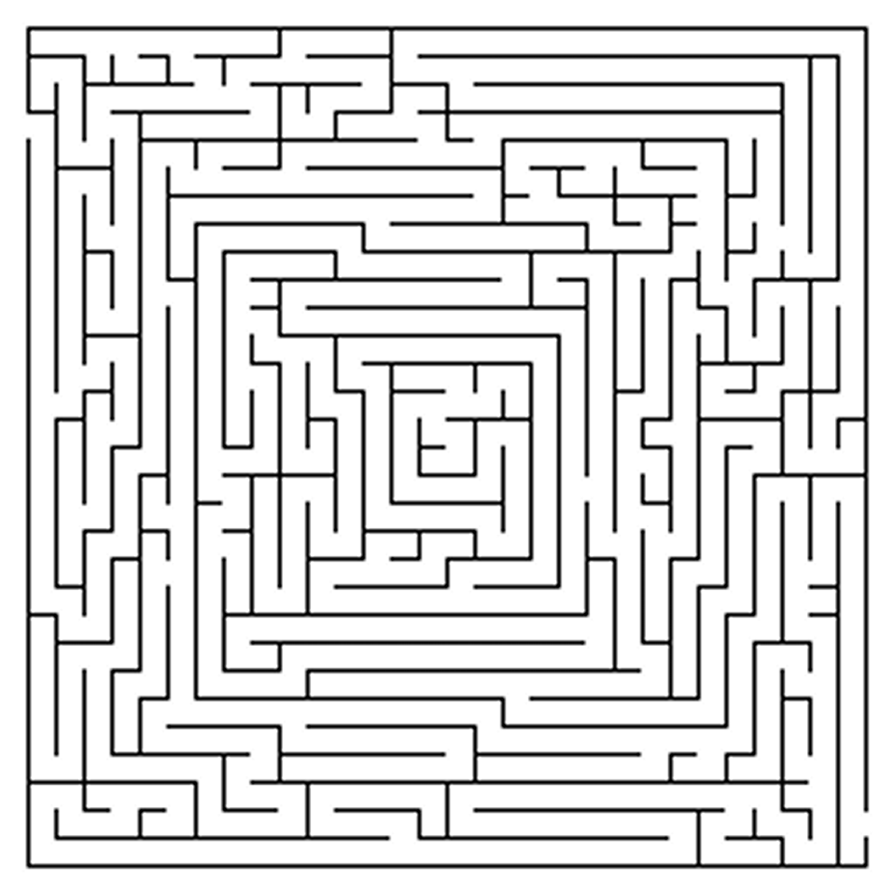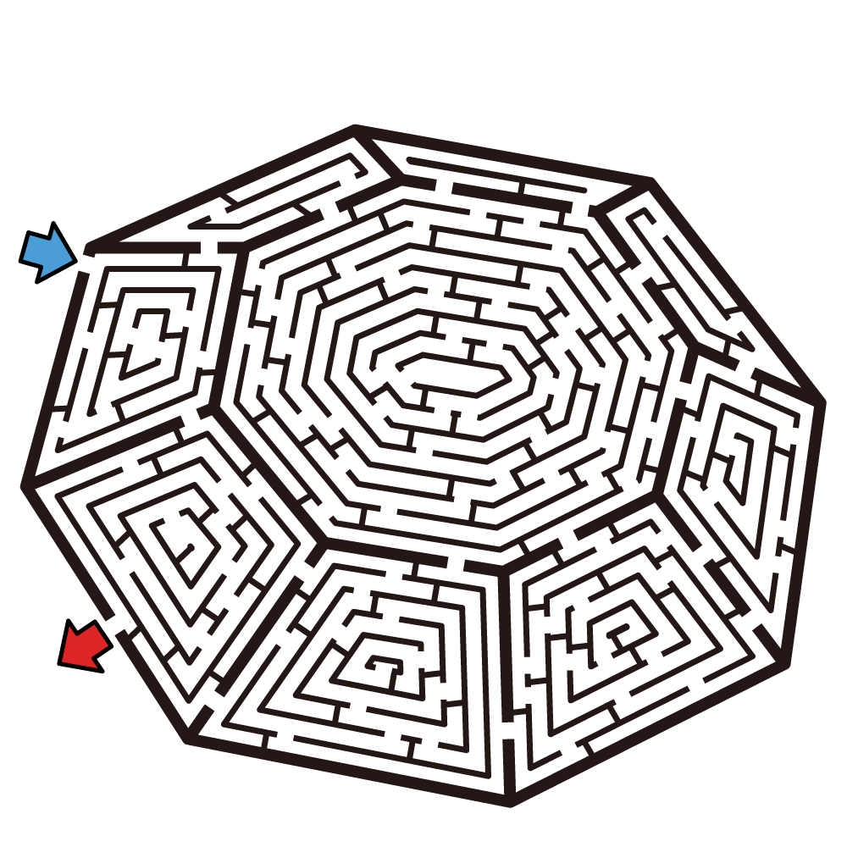

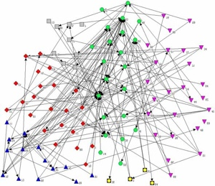 Maths Masterclass March 2023

The University of Bath

How to amaze your friends

Session Two

1. Think of some examples of networks in the real world.
2. Take one or more of the mazes shown overleaf. Draw a network diagram for the maze. Now solve the maze using your diagram.
3. Which of the mazes you’ve seen today can be solved using the hand on the hedge method?
4. See if you can make a friendly network. To do this, make yourself a node and think of everyone else in the room as another node. Draw an edge from one node to the other if the two people are friends. If you compare your network with others in the room then you can try to make a GIANT FRIENDLY NETWORK for the whole room (or even for everyone attending the masterclass).
5. Take any of your networks and count up the number of odd nodes. You should find out that it is always an even number. Can you work out why?
6. Look at the network diagrams you’ve drawn. Count the number of nodes N, edges E and faces F. Now work out N+F-E. Draw another network and work out N+F-E for that. What do you notice?

