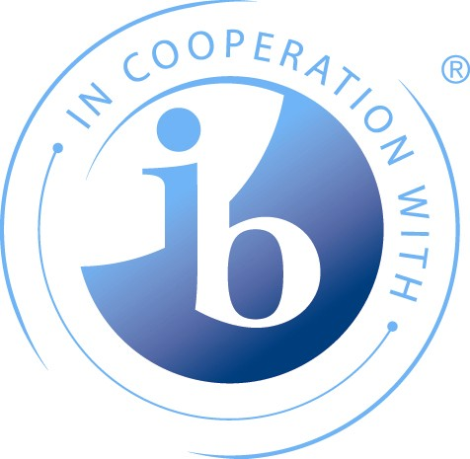


Guidance about the MA Education Curriculum Studies (CS) Unit & the
International Baccalaureate Educator Certificate in Teaching and Learning

1. Introduction
These notes are intended to brief you about the International Baccalaureate Educator Certificate (IBEC) and to explain what you need to do if you want to use this unit to help you to gain the IBEC.

i] This document should be read alongside, ‘Guidance about the IB Educator Certificates in Teaching & Learning: A summary of what you need to do’ which explains the process of registration to study the IBEC.

ii] The content of this unit will be the same regardless of whether or not you are using it to gain the IBEC or not; the difference is in the assignment you prepare for assessment. So, in your unit studies, there will be reference to the IB Programmes as you would expect. In addition, you will reflect on and analyse your experience as an IB teacher to develop your knowledge and understandings in this unit.

iii] If you are using this unit towards the IBEC you need to shape your assignment in a particular way so that you address a set of 'Essential Questions’ associated with ‘domains of knowledge’. The following section explains what these Essential Questions are.

2. The Essential Questions
SUMMARY
- For each of the four units required for IBEC there are a set of unit-specific Essential Questions to answer.
- In addition, there are three ‘professional’ Essential Questions (A, B & C) to be answered from across the four units.
- You need to summarise the evidence for your answers on the form: ‘Evidence summary for the International Baccalaureate Educator Certificate’.
- There is one form for each unit which can be found on the unit Moodle course and in the IBEC wiki.
- Throughout your assignment work towards the IBEC you need to draw on one only of the IB programmes from PYP, MYP or DP.

To gain the IBEC you need to demonstrate that you have reached a particular level of IB-related expertise. The expertise is specified as areas of enquiry:
- Curriculum Processes
- Teaching and Learning
- Assessment and Learning and
- Professional Learning.

Within the areas of enquiry, there are various Domains of Knowledge. So, one Domain of Knowledge for Curriculum Processes is ‘Curriculum and Instructional Design’. For teaching and learning, one of the Domain of Knowledge is ‘Learning theories, strategies and styles’.

For each Domain of Knowledge there is an Essential Question, which you have to answer by providing evidence in your unit assignments. For the examples given above, the Essential Questions are as follows:
Domain of Knowledge | Essential Question
Curriculum and instructional design | How will the participants demonstrate their ability to synthesize the essential elements of the PYP/MYP/DP?
Learning theories, strategies and styles | How will the participants demonstrate their ability to undertake appropriate planning, development and reflection processes that support the achievement of DP learning outcomes?

All of the Essential Questions for the IBEC can be answered by taking the four specified MA Education units and completing the assignments in such a way that you provide clear evidence that you have answered all of the Essential Questions. There is a different set of Essential Questions for each unit, and a different form to complete with a summary of evidence for each unit. These ‘Evidence summary for the International Baccalaureate Educator Certificate’ forms can be found on the Moodle course for each unit and the IBEC wiki.
The overall shape of the IBEC shown in the diagram below.
The Requirements of the IBEC
The four Areas of Enquiry
The Domains of Knowledge for each area. There are between three and five for each one.
The Essential Questions - one for each Domain

Important: The Professional Learning Area of Enquiry has three Domains of Knowledge that cover general areas of professional expertise. They are:

- The principles and processes of reflective practice
- Collaborative working: planning implementation and evaluation.
- The use of ICT to support the building of communities of practice.

You only need to answer the Professional Learning Essential Questions (A, B &C) once across the four units; this means you can chose where in your four assignments you provide the answer to each professional Essential Question. You could therefore in theory answer all three professional Essential Questions in one assignment! You are advised to look for opportunities to answer the professional Essential Questions as you write each assignment.

3. The Essential Questions and the CS Unit
Essential Questions related to the CS Unit
- How have you demonstrated your understanding of the PYP/MYP/DP’s underpinning educational principles and how these are incorporated into the curricular structure to create meaningful learning experiences?

- How have you demonstrated your ability to synthesize the essential elements of the PYP/MYP/DP?

- How have you demonstrated your ability to identify and critique the key areas of commonality and difference in the three IBO programmes?

- How have you demonstrated your ability to select and use a range of appropriate teaching and learning resources that support the achievement of PYP/MYP/DP learning outcomes?

Essential questions related to the ‘Professional learning area of enquiry’
NOTE: The Essential Questions that relate to the Professional learning area of enquiry only need be answered once across all four units
- How have you demonstrated your ability to undertake critical evaluation of planning, teaching and assessment activities, and learning resources to assess their impact on student learning and where necessary revise PYP/MYP/DP practices?
- How have you demonstrated your ability to participate in and undertake critical evaluations of collaborative working practices intended to promote PYP/MYP/DP learning outcomes?
- How have you demonstrated your ability to participate in and evaluate the use of information and communication technologies to engage within the wider IB community to further develop PYP/MYP/DP learning outcomes?

When you are developing your assignment outline (assignment title and the proposed content of the assignment/ indicative reading) and negotiating this with your tutor, you will need to ensure that your assignment will enable you to answer the specific Essential Questions. Bear in mind that you will have to provide evidence for the Professional Learning Essential Questions once in either this assignment or assignments for the other three units.

When you submit your assignment for this unit you will need to complete the ‘Evidence summary for the IBEC’ form for the CS Unit. The form indicates to your tutor how you have answered the questions. You need to specify where in the assignment – that is, on which pages and in which sections - you have answered the Essential Questions. Your tutor will check that your evidence summary is correct, sign the form accordingly and return it to you via Moodle (the form will be uploaded to Moodle with your feedback). You must pass the unit for your evidence for the Award to be valid. If you pass the unit but have not provided sufficient evidence for the IBEC, you cannot submit additional evidence.

ADVISORY NOTES:
- If you submit a draft form with your draft assignment your tutor can advise on any further work needed to answer the Essential Questions.
- Tutors find it helpful when the student highlights the specific evidence for the Essential Questions within the text of the draft assignment as well as using page numbers and section headings in the summary form.
- If it is not clear where the evidence is there is a risk that the tutor may inadvertently find there is insufficient evidence.

4. What to do if this is your last unit
If the CS Unit is your last unit of the four specified units and if you have provided evidence for all of the Essential Questions (including Essential Questions A, B & C related to Professional Learning which must all be evidenced at least once from across the four assignments), you can register for the IB Educator Certificate by completing the registration form available from the Administrator Rachel Potter r.c.potter@bath.ac.uk

