Parallel Computing
CM30225
Russell Bradford
2023/24

1. Classifications

Vectors
In a vector processor, the bottleneck to the shared memory still needs thinking about
For reads: as the cores are all doing the same thing, if one requests a global shared value from a fixed shared memory location, then all of them are doing the same
So the memory system puts that single value on the bus and all the cores read it: no bottleneck
Sometimes called a broadcast

2. Classifications

Vectors
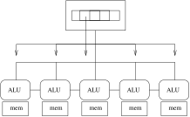
One read goes to all cores

3. Classifications

Vectors
However, as is often the case, it can be that each core wants a value from a different part of global memory. E.g., core $k$ wants the $k$th element from a array
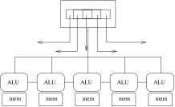
Reading a vector of values

4. Classifications

Vectors
In this case, it takes careful management, both by the hardware and by the programmer, to ensure the transfers use the shared memory bus efficiently
The case of sending the sending the $k$ item to the $k$th core is often optimised by the hardware using coalescence
Using a wide bus (e.g., 512 bits) a single read operation can fetch multiple data (e.g., 16 integers) and put them all on the bus simultaneously
Each core reads the value it wants
The next 16 values are sent in the next transfer; and so on

5. Classifications

Vectors
A single fat read goes to multiple cores

6. Classifications

Vectors
However, it needs data accesses in the program to be of certain patterns for this to work, e.g., linear access to an array
The kinds of access pattern allowed for coalescence are dependent on what the hardware supports, but are generally picking some subset of a contiguous chunk of the shared memory
Otherwise, the reads cannot be coalesced and might require many (e.g., 16) individual reads: much slower
E.g., proc $k$ wants value $k^{2}$ from the array

7. Classifications

Vectors
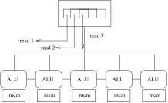
Awkward distribution done in multiple reads

8. Classifications

Vectors
Similarly for writes: e.g., core $k$ writing a value to the $k$th slot in an array could be coalesced
Multiple writes to a single location make no sense and are often disallowed by the system
Exercise Consider the case of indirecting through a pointer to global memory (a) when each core points to the same location and (b) when each core points to a different location in the global memory
Exercise Consider the case of indirecting through a pointer to local memory (a) when it’s pointing to the same location on all cores and (b) when it’s pointing to a different location on each core

9. Classifications

Vectors
Often there is fast direct communications between neighbouring CPUs
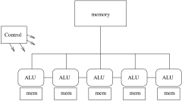
Neighbour connections
This allows data to shuffle up and down the vector very quickly: many problems (e.g., differential equations solving) work on data and neighbour data in this way

10. Classifications

Arrays
Clearly, vector processors are SIMD and not suitable for MIMD or even SPMD
Vector processors appeared early in parallel computing as they are relatively easy to build: ALUs are relatively easy to build and replicate, while control units are complex and hard

11. Classifications

Arrays
An extension of the idea was the array processor
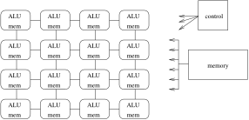
Array processor
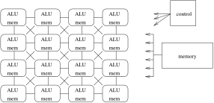
Array with diagonal connections

12. Classifications

Arrays
The CPUs are in SIMD lockstep as before, but now in an array
Fast connections in two or more directions
This fits well with 2 dimensional differential equation problems
More expensive than vector processors and much less common

13. Classifications

Arrays
Early array processors were very simple, but they became bigger as technology advanced
 |  | CPU | #CPUs | mem/CPU
DAP | 1979 | 1 bit | 4k | 4k bits
CM | 1983 | 1 bit | 64k | few kB
MPP | 1983 | 1 bit | 16k | 1 kB
MasPar | 1990 | 4 bit | 16k | 16kB
MasParII | 1992 | 32 bit | 64k | 64kB
DAP: ICL Distributed Array Processor
CM: Connection Machine (pretty lights)
MPP: Goodyear Massively Parallel Processor

14. Classifications

Arrays
Despite being very wimpy processors, this was made up by having so many of them
Their throughput (results achieved per second) is quite respectable
They work very well for certain kinds of problem (e.g., weather forecasting), but are not suited to many other kinds of problems
Vector/array processing processors are important due to their influence on the design of GPUs

15. Classifications

Arrays
Shared, distributed and vector processors are the three major architectures used today
But others have been tried, with varying levels of success

16. Classifications

Pipelines, Systolic Arrays
Similar looking to vector processors, but actually quite different, are systolic arrays
These generalise CPU instruction pipelines to processes
Process pipeline
The CPUs are independent (MIMD/MPMD), each performing one step in the transformation of the input data
More often found in hardware to solve specific problems; not often found as a generic machine
Exercise Could this be classified MISD?

17. Classifications

Pipelines, Systolic Arrays
For example, a graphics card might want to do clipping of polygons, then colouring, then shading
Each step separate, but compute intensive
Just as pipelining instructions in a processor allows instructions to be processed faster, pipelining these kinds of computations allows pixels to be computed faster
Used in graphics coprocessors as another form of parallelism
Part of the reason why digital TV is delayed relative to realtime is that the encoding of the picture goes through a big pipeline before it is transmitted: there is an inherent latency in pipelines

18. Classifications

Pipelines, Systolic Arrays
Systolic arrays are the obvious extension
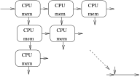
Systolic array
but it is unclear if these were ever built

19. Classifications

Extensions of von Neumann
So why do all these varieties of parallel architecture exist?
There is essentially just one way uniprocessor machines are built: the von Neumann model
Is there a model that encapsulates multiprocessors in the same way?
There are many contenders, but no obvious winner

20. Classifications

Extensions of von Neumann
We have the original von Neumann 5 box model
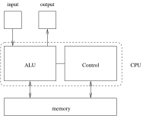
von Neumann 5 box model

21. Classifications

Extensions of von Neumann
Shared memory MIMD
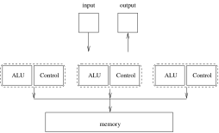
Shared memory box model

22. Classifications

Extensions of von Neumann
Distributed memory MIMD
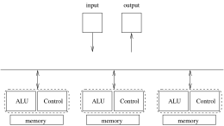
Distributed memory box model

23. Classifications

Extensions of von Neumann
Vector processor
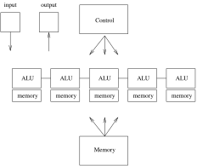
Vector processor memory box model

24. Classifications

Extensions of von Neumann
Perhaps there just isn’t a single extension of von Neumann that is suitable as a one-size-fits-all solution
Or perhaps we just haven’t thought of it yet?

25. Classifications

Extensions of von Neumann
There are several theoretical models whose aim is to guide the design of parallel algorithms and allow the analysis of them
As with von Neumann, the idea is that you
- write your program in accordance with the model
- the model maps well onto all kinds of real hardware
- therefore your program maps well onto all kinds of real hardware

26. Classifications

Extensions of von Neumann
Firstly: PRAM
The Parallel Random Access Machine model idealises a parallel computer as shared memory MIMD, concentrating on the memory bottleneck
You have a choice of how memory can be accessed:
- Exclusive Read Exclusive Write (EREW). Each memory location can only be read or written by one processor at a time. The simplest architecture
- Concurrent Read Exclusive Write (CREW). Each memory location can be read by many processors simultaneously, but written by just one processor at a time (c.f. global memory in a vector processor)

27. Classifications

Extensions of von Neumann
- Concurrent Read Concurrent Write (CRCW). Each memory location can be read or written by many processors simultaneously. Not a realistic model
- Exclusive Read Concurrent Write (ERCW). The fourth combination, never used.

28. Classifications

Extensions of von Neumann
PRAMs make many further simplifying assumptions, including:
- Memory is symmetric: every location is accessed at the same speed. Decreasingly realistic
- There are an unlimited number of processors: there’s always another processor if you need it. Seems unrealistic, but not so bad as you think as most programs are unable to make use of the hardware that we currently have
- Memory is unlimited. This assumption is also often made in analysis of uniprocessor algorithms

29. Classifications

Extensions of von Neumann
In the early days of Computer Science, there were many clever algorithms invented to deal with the lack of available memory
And, to some extent, memory is still limited in some modern architectures that have very large numbers of CPUs so proportionally each has only a small share of memory
And people want to run programs on datasets of ever-increasing size

30. Classifications

Extensions of von Neumann
So you analyse your program, counting numbers of memory accesses it makes (according to which of EREW/CREW/CRCW you have chosen) and this gives you a measure of the time your program will take to run
This is primarily a MIMD model, but you can analyse SIMD using it
It totally ignores important realities like NUMA and other overheads, such as communication time in a distributed memory system
But it gives you a rough idea and it is extensively used in analysis of parallel algorithms: we’ll have some examples later

31. Classifications

Extensions of von Neumann
Next: BSP
The Bulk Synchronous Parallel model
This model takes communication time into account
It assumes processors with local memory communicating over a network
Good for distributed, but can be used for shared memory where you just have smaller communication costs

32. Classifications

Extensions of von Neumann
A computation is modelled as a sequence of supersteps
- each processor does some computation (MIMD, but could be SIMD)
- each processor does some communication
- each processor waits at a global barrier until everybody has finished their communications. This is the “bulk synchronous” part
- repeat

33. Classifications

Extensions of von Neumann
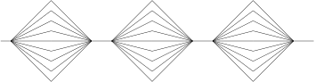
BSP supersteps

34. Classifications

Extensions of von Neumann
Processing is simplified in this way to give us a chance of being able to make an analysis
Fortunately, many real computations are not too far from this shape
More realistic than PRAMs, but harder work to get analyses out of it
But those analyses tend to be a better match to realistic hardware

35. Classifications

Extensions of von Neumann
And so on for many other models, some practical, some not
For example, parallel Turing machines and Communicating Sequential Processes (CSP) amongst others. Both better at describing the nature and limitations of parallel programs than for investigating how well they work
But the fact remains that there is not one simple theoretical model that works well for all kinds of parallel processing
This might be the source of the confusion in parallel hardware, but we have to live with it

36. Analysis
So we need to look at how to analyse parallel algorithms
Analysis of parallel algorithms is like analysis of sequential algorithms, just more complicated
Later we shall see statements like “this takes time $O\left(n^{2}\right)$ using $O\left(p\right)$ processors”
But we shall start with a few simple measures that we can use to indicate how well our parallel algorithms are working
They are quite crude, but effective

37. Analysis

Speedup
They mostly measure the parallel algorithm in comparison with a corresponding sequential algorithm
Or a parallel implementation with a corresponding sequential implementation: by timing actual running code
We have seen that having $p$ processors won’t necessarily make our program run $p$ times as fast
The speedup using $p$ processors is
$$S_{p}=\frac{\text{time on a sequential processor}}{\text{time on }p\text{ parallel processors}}$$
Ideally we’d like $S_{p}=p$, but this never happens

38. Analysis

Speedup
Usually $S_{p}$ is much smaller than $p$ for several reasons
Firstly, there is communications overheads between processors
This might be fairly small for shared memory, or large for distributed memory, but it is present
Time spent communicating is time not spent computing

39. Analysis

Speedup
So more communications (data movement) will tend to lead to smaller speedups
For example, speedups on distributed memory machines can be reduced as the cost of communications is quite high
But speedups can improve for a larger computation where the relative cost of communications drops
Remember clusters are used for large problems where the emphasis is on size, not speed

40. Analysis

Slowdown
In really bad cases, $S_{p}<1$, i.e., our parallel program goes slower than our sequential program even though we’ve thrown all this expensive hardware at it!
This is more common than we’d like

