Networking
CM30078/CM50123
Russell Bradford
2022/23

1. Networks

Ethernet
What are the physical encodings of bits on a 10Mb/s Ethernet?
A simple way would be 0V for 0 and 1V for 1, running at 10MHz
But this has a number of problems

2. Networks

Ethernet
1. An empty network and a stream of 0s looks the same
And so you could not do carrier sense
2. Bits need to be synchronised to prevent drifting out of step (was that 1000 or 999 0s?)
3. A long stream of 1s is a steady 1V: this is electrically a bad design, an average 0V is best
To connect devices easily you need an AC signal, not a DC one

3. Networks

Ethernet
So 10Mb/s Ethernet uses a Manchester Encoding
- Split the time interval for a bit into two parts
- Low then high voltage is a 0
- High then low voltage is a 1
So the average is 0V
-0.85V for low, +0.85V for high
This voltage is a compromise: a bigger voltage gives a more robust signal that will travel further, but it uses more power

4. Networks

Ethernet
Easy to synchronise: the transit through 0V is the middle of a bit
This does double the frequency of the signal to 20Mhz
We can use Cat 4 (or better) cable for this
Manchester encoding solves the above problems neatly and actually simplifies the hardware needed
It is described as self clocking, as the reading end does not need a clock to determine where the bits are

5. Networks

Ethernet
What of 100Mb/s Ethernet?
We can’t use even Cat 5e cables with Manchester as it is only specified to 100MHz, and we would need 200MHz

6. Networks

Ethernet
Instead we start by encoding 4 data bits as 5 physical bits in a 4B/5B encoding; e.g., 0000 become 11110
Input | 4B/5B | Input | 4B/5B
0000 | 11110 | 1000 | 10010
0001 | 01001 | 1001 | 10011
0010 | 10100 | 1010 | 10110
0011 | 10101 | 1011 | 10111
0100 | 01010 | 1100 | 11010
0101 | 01011 | 1101 | 11011
0110 | 01110 | 1110 | 11100
0111 | 01111 | 1111 | 11101
With some control patterns, e.g., IDLE 11111.

7. Networks

Ethernet
Hasn’t 4B/5B made things worse: 5 bits where there were 4?
But now we use a three level physical encoding MLT-3
This has +, 0, and - levels ($±0.85$V), again using transitions to encode bits

8. Networks

Ethernet
Transitions are cyclical
- to 0
0 to +
+ to 0
0 to -
A transition marks a 1, no transition marks a 0
The 4B/5B translation ensures that every chunk of 5 symbols has at least two transitions, so average voltage is roughly 0
E.g., input 0000, with no transitions becomes 11110 with four transitions

9. Networks

Ethernet
An example. Hex value 0E = 0000 1110
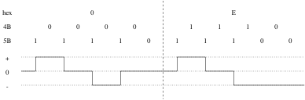
MLT encoding

10. Networks

Ethernet
Some words:
A physical representation is called a symbol
Symbols need not be binary
And need not represent a whole number of bits
The baud rate is the number of symbols per second

11. Networks

Ethernet
100Mb/s Ethernet runs at up to 31.25MHz for a symbol rate of 125MBaud: all 1s output (IDLE) is four transitions (- to 0, 0 to +, + to 0, 0 to -) per cycle ($\text{4 symbols/cycle}×31.25\text{MHz}=125\text{MBaud}$)
This has a symbol rate of 125MBaud for a data rate of 100Mb/s: 80% efficient or 1 physical symbol is $4/5=0.8$ bits

12. Networks

Ethernet
For Gigabit Ethernet 1000Base-T: 8 bits become $4×3$ physical bits in a continuously changing encoding (not a table lookup)
Each 3 bit chunk is encoded using transitions between 5 levels (PAM-5)
Over all four pairs in the cable simultaneously, in both directions on all pairs
10Gb Ethernet uses a PAM-16 over a very complicated coding (Tomlinson-Harashima Precoding)
(SATA and USB 3.0 use 8B/10B; USB 3.1 uses 128B/132B; etc.)

13. Networks

Ethernet
And then there is Ethernet over optical fibre…
Exercise Read about the physical encodings that are used in fibre

14. Bridging
Some time ago we talked about bridges joining networks
ARP bridging is fine for joining a pair of small networks, but less so for larger collections of networks
The IEEE 802.1d Ethernet Bridging standard addresses this, dealing with the cases of multiple routes between hosts

15. Virtual Bridging
And a common variety is 802.1q virtual bridging
More commonly called Virtual LANs (VLANs)
This is a kind of reverse of the ARP bridge: it allows more than one network to run on a single physical network

16. Virtual Bridging
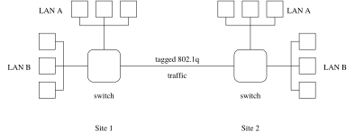
Virtual bridge
A company has two separate sites 1 and 2 with a single dedicated link between them; They want to run two separate LANs, A and B, but not to buy a second link between the sites; They can use 802.1q tagging; A packet from LAN A in Site 1, say, arrives at the switch; The switch knows to route the packet over the remote link: it places a 802.1q tag on the frame; A tag is an extra four byte header containing a Virtual LAN Identifier (VID), a 12 bit integer; The frame type in the physical layer (typically Ethernet) is changed from 0800 to 8100 to indicate a tagged packet; The switch in Site 2 receives the packet, sees the tag, reads and removes it and forwards the packet to its part of LAN A

17. Virtual Bridging
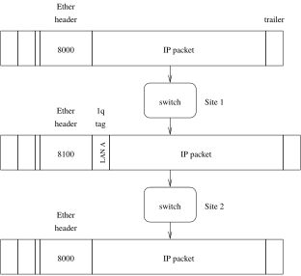
Tagging packets in a VLAN

18. Virtual Bridging
This generalises well to many virtual LANs and allows many networks to share infrastructure, thus saving on cost
Note: this is quite different from Virtual Private Networks (VPNs), which we shall talk about later
Exercise Look up the structure of a VLAN tag
Exercise The University uses VLANs extensively. Find out about this
Exercise How does tagging interact with maximum frame sizes, e.g., in Ethernet?

