Networking
CM30078/CM50123
Russell Bradford
2023/24

1. TCP Strategies

Silly Window Syndrome
Another problem with tinygrams is manifested as silly window syndrome

2. TCP Strategies

Silly Window Syndrome
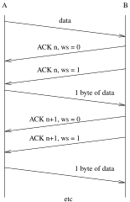
Silly Window Syndrome
A is sending data to B, but B’s buffer is nearly full and B is reading only one byte at a time; B’s buffer fills, and B ACKs with a window of 0; A holds off sending more data; B reads a byte; B sends a window update segment, size 1; A get this and sends as much data as possible, i.e., 1 byte; B ACKs with window 0; B reads a byte; B sends an update, size 1; A sends 1 byte; And so on

3. TCP Strategies

Silly Window Syndrome
We are back to the two segment per byte high overhead: this is silly window syndrome
Better is for B not to send an update of 1, but wait until there is more space
Clarke’s algorithm to avoid SWS is in the server
never send an update for a window of 1; only advertise a new window when either (a) there is enough space for a full segment, or (b) the buffer is half empty

4. TCP Strategies

Congestion
Nagle (in the client) and SWS (in the server) fit together naturally
Note that TCP code doesn’t have to implement Nagle or SWS or delayed ACKs or any of these strategies: it’s just a good idea if it does!

5. TCP Strategies

Congestion
Nagle and SWS are good for when there is a small amount of data being transmitted
We need to look at the case of sending large amounts of data
We want the data to get to the destination as fast as possible, but we now have to consider not just the ability of the destination to cope, but also the capacity of the network itself

6. TCP Strategies

Congestion
Congestion happens when more data is being sent than the network can handle: routers will drop packets if there is not enough onward bandwidth to cope
There are several strategies in TCP to help deal with and avoid congestion
The first issue is how to spot congestion, given that it might be happening in a part of the network many hops away from both source and destination

7. TCP Strategies

Congestion
We watch for segment loss
Segments can be lost though errors in transmission or being dropped at a congested router (or at the destination)
Poor transmission is less usual these days, so we can assume loss is due to congestion (which is common these days)
Thus TCP treats missing or duplicate ACKs as a sign of congestion
Exercise A missing ACK is understandable as a sign of congestion: reflect briefly on why duplicate ACKs can be caused by congestion

8. TCP Strategies
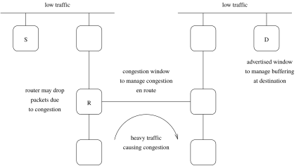
Congestion somewhere on the path
Congestion can happen in a router due to lack of capacity in an onward link; a router will drop a packet if it can’t cope

9. TCP Strategies

Congestion
Just as the advertised window deals with “congestion in the destination” (it’s not really congestion), we have the congestion window for congestion in the network
So how do we determine the congestion window? It’s not a thing the source or destination can know directly
We do this by sending segments and watching what ACKs we get

10. TCP Strategies

Congestion
If we have a lot of data to send we do not want to wait for each ACK before sending the next segment
Better is to send several segments and then wait to see from the ACKs which were safely received

11. TCP Strategies

Congestion
But sending too many segments at once is bad when the network is congested: our segments will be dropped. We’ll just be making things worse for everyone, including ourselves
So, if we have an estimate of the capacity of the network (the congestion window), we will be sending many segments at once, but not too many
If we get it right, we will have a continual stream of segments going out and ACKs coming back

12. TCP Strategies

Slow Start & Congestion Avoidance
We estimate the network congestion by watching the number of ACKs coming back
This estimate controls the congestion window
This is an another constraint on sending additional to the advertised window: it’s a bad idea to send more data than indicated by the either window

13. TCP Strategies

Slow Start & Congestion Avoidance
We describe a basic flow control strategy (RFC2001/RFC2581) that estimates the congestion window; many modifications exist (TCP Tahoe, TCP Reno, TCP Vegas, …)
The congestion window (cwnd) is initialised to the maximum segment (MSS) size of the destination
A variable, ssthresh, the threshold, is initialised to 64KB (say)
Every time a timely ACK is received, the congestion window is increased by one segment

14. TCP Strategies
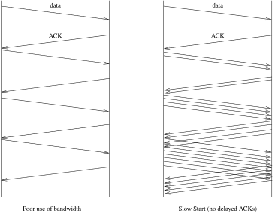
Slow Start with no delayed ACKs

15. TCP Strategies
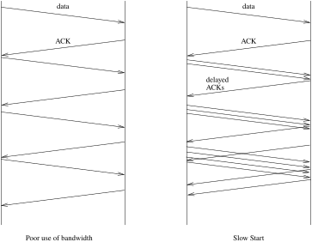
Slow Start with delayed ACKs

16. TCP Strategies

Slow Start & Congestion Avoidance
So initially we send one segment
Then two at a time
Then four…
This is called slow start

17. TCP Strategies

Slow Start & Congestion Avoidance
It is actually a near-exponential increase in the congestion window over time
It is “slow” in comparison with an earlier version of TCP that started by blasting out segments as fast as possible before the performance of the network was known
In slow start, the increase continues until we reach the current threshold ssthresh or returning ACKs are duplicated or timed out

18. TCP Strategies

Slow Start & Congestion Avoidance
Of course, the rate is also limited by the advertised window of the destination: we can only send the minimum of the current congestion window and the advertised window
Note that the congestion window is a limit set by the sender, while the advertised window is a limit set by the receiver

19. TCP Strategies

Slow Start & Congestion Avoidance
If we reach ssthresh without a problem, we change to the congestion avoidance phase
Now we increase the congestion window cwnd by one segment for each round trip time (RTT)
So one per burst of segments
This is now a linear increase over time

20. TCP Strategies

Slow Start & Congestion Avoidance
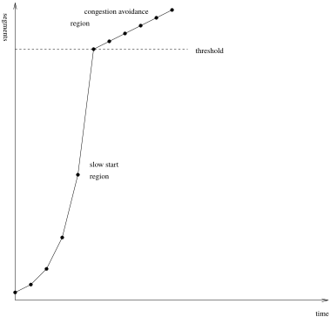
Slow start and congestion avoidance regions

21. TCP Strategies

Slow Start & Congestion Avoidance
Eventually the network’s limit will be reached and a congested router somewhere will start dropping segments
The sender will see this when either (a) it gets some duplicate ACKs, or (b) there is a timeout waiting for ACKs
Note we might be in either of the slow start or the congestion avoidance phases when congestion occurs: particularly if ssthresh was initially set very large, as its often done these days

22. TCP Strategies

Slow Start & Congestion Avoidance
When congestion is detected
- the threshold ssthresh is set to half the current transmit size. This is the smaller of the current congestion window and the advertised window. Also, this is rounded up to a minimum of two segments
- if it was a timeout, the congestion window cwnd is set back to one segment, and go back into slow start
- when ACKs start coming through, we resume increasing the congestion window again, according to whether we were in slow start or congestion avoidance (i.e., whether cwnd is less than ssthresh or not)

23. TCP Strategies
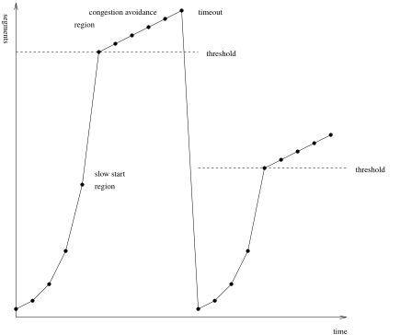
Converging on the optimum rate
The sender eventually converges on a rate that is neither too fast, nor too slow

24. TCP Strategies

Slow Start & Congestion Avoidance
And it is dynamic
If conditions on the network change, it will soon adapt to the new rate, be it faster or slower
If there is no congestion on the network, the rate increases until it reaches the advertised window: the limiting factor is then the destination, not the network
This strategy is very effective: get the flow up quickly, but don’t overshoot network capacity. Also, back off quickly and try again when a loss happens

25. TCP Strategies

Fast Retransmit
As previously mentioned, when an out-of-order segment is received the TCP protocol calls for an immediate (possibly duplicate) ACK: it must not be delayed
Thus the sender will start seeing duplicate ACKs
This is to inform the sender as soon as possible that something is wrong
Jacobson’s Fast Retransmit strategy builds on the idea that the receipt of several duplicated ACKs is indicative of a lost segment

26. TCP Strategies

Fast Retransmit
Recall that the argument is that one or two duplicate ACKs might simply be due to out-of-order delivery, as IP is unreliable
Three or more is taken to mean something is wrong
If this happens, the sender should retransmit the indicated segment immediately: fast retransmit

27. TCP Strategies

Fast Recovery
Next, Jacobsen says do not go into slow start but do congestion avoidance: this is the fast recovery strategy
We don’t want slow start as the duplicate ACKs indicate that later data have reached the destination and is buffered there
So data is still arriving (mostly) and we don’t want to abruptly cut the flow by doing slow start
Fast Retransmit & Fast Recovery are quite effective at getting the flow going again after a loss
Exercise Read RFC2001 for the details we have not mentioned here

28. TCP Strategies

Congestion
There have been many tweaks to this basic flow control strategy
- Larger initial ssthresh
- Larger initial cwnd
- Slow start counting number of segments ACKed, not just the number of ACKs
- Treating duplicate ACKs like a timeout
- On timeout, setting cwnd to half ssthresh, not just 1 segment
- Fast recovery: wait for the ACK of the entire transmit window before entering congestion avoidance
- Many more

29. TCP Strategies

Congestion
Exercise Read about other strategies, such as TCP Reno, TCP Vegas, TCP New Reno, TCP Hybla, BIC, CUBIC, etc.

30. TCP Strategies

Congestion
And other kinds of congestion strategy exist and are used
For example, BBR (specifically BBRv3) from Google is not (primarily) loss based, but develops a model of the state of the network by monitoring RTTs and the achieved bandwidth of a connection
It remembers and uses past behaviour as a predictor: not just the current ACK loss behaviour
Of course, this involves a lot of CPU cycles and could not have been done in the early days of the Internet
Exercise Read about this

31. TCP Strategies

Congestion
Other strategies involve the routers — they are where the congestion is happening, after all!
Particularly Explicit Congestion Notification (ECN), which aims to indicate congestion before it happens by routers setting flags in the IP TOS/DS header when they think congestion is imminent, so that the hosts get forewarning and can slow down
Exercise Read about ECN and its use of flags in both the IP header and the TCP header

32. TCP Strategies

Congestion
Exercise Read about Random Early Detection/Drop (RED), which is also used in routers
Exercise We use ICMP to indicate other kinds of errors, but why is it not a good idea to use ICMP when a router drops a packet due to congestion?

33. TCP Strategies

tcpdump
Exercise Use tcpdump to watch these strategies in operation. The netcat program is an easy way to set up connections and send data

36. TCP Strategies

Path MTU Discovery
The next strategy we have seen already: it is aimed at getting the largest segment size a connection can handle. But not too large
IP layer fragmentation is expensive, so we employ path MTU discovery: but now we need to look at it from a TCP perspective
TCP has (potentially) more information: namely the optional MSS header sent in the setup handshake

37. TCP Strategies

Path MTU Discovery
We can send segments of decreasing size, starting with the minimum of the MSS of the sending interface and the MSS announced by the other end, or 536 if the other end did not give an MSS
And with the IP flag DF (Don’t Fragment) set
Note the cross-layer activity here!

38. TCP Strategies

Path MTU Discovery
If an ICMP error “fragmentation needed but DF set” happens during a TCP connection, the congestion window should remain unchanged, but it should only resend one segment before ACKs start appearing again
This is to reflect the fact that it’s not congestion at fault here, but we do need to back off a bit to allow ACKs to start coming through again
It is recommended you try a larger MTU once in a while, e.g., every 10 minutes, as routes can vary dynamically

