Networking
CM30078/CM50123
Russell Bradford
2023/24

1. TCP

Flow Control
- 16 bits of advertised window size: for flow control
TCP implements flow control, i.e., adjusting the rate of sending packets up or down to make best use of current conditions (a) in the network and (b) in the receiving host
The advertised window deals with (b)
The destination has only a limited amount of buffer memory it can store new segments in
If the application is not reading the data as fast as it arrives, the buffer will fill up

2. TCP

Flow Control
The window size is the amount of buffer the receiver has left: the receiver sends this value in each segment going back to the sender
If the space left is very small, the sender can slow down sending until space in the receiver is freed up

3. TCP

Flow Control
Initially B has space 100 in its buffer
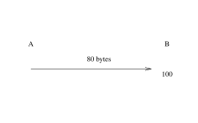
A sends 80 bytes
B save the data in its buffer
On the next returning segment, B advertises 20
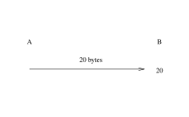
A now knows it shouldn’t send more than 20
Next advertisement would be 0
Until B reads some of the data
And can advertise the space

4. TCP

Flow Control
Thus B can tell A to slow down or speed up as appropriate to its remaining buffer space
16 bits gives a maximum buffer of 65535 bytes: much too small for modern hosts that have megabytes to play with
There is a header option to scale this up to something reasonable
Symmetrically, A has its own advertised window that it sends to B
The other flow control mechanism to deal with varying conditions in the network comes later

5. TCP
- Checksum of the header, the data, plus some fields of the IP layer
Again, bad design!
- Urgent pointer: active if the URG flag is set
The urgent pointer is a pointer into the data stream that indicates where the current urgent data block ends
Urgent data includes things like interrupts that need to be processed before any other data that is buffered

6. TCP
The OS should notify the application when an URG is received, e.g., using an interrupt
The OS interrupt code would then read through the urgent data block and act appropriately on what it finds there

7. TCP
In a similar vein we have the
- PSH flag: set to indicate the destination OS should pass data to the application as soon as possible
The destination OS might be holding back data for some reason before passing it on to the application, e.g., collecting together segments into one large buffer for efficiency reasons
Or holding back notifications to the application that data has arrived: again not to swamp the application with loads of notifications of small amounts of data
This flag says send the buffered data to the application, don’t wait

8. TCP
Originally it was intended the client application could set the PSH when it felt the server should not be hanging about buffering data
These days, there is no mechanism (in the sockets API) for applications to specify this, but the TCP software itself sets PSH when appropriate, e.g., when the client’s send buffer empties
The idea here is that there is no point for the receiver waiting for more data, as there is no more to send right now

9. TCP
After the fixed header there are the options, including window scale and maximum segment size
After the options header is the data, which can be empty, e.g. for a pure ACK

10. TCP

Options
TCP Options are many and varied
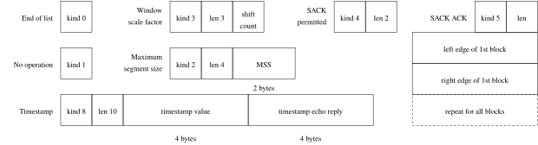
Some TCP optional headers

11. TCP

Options
Options start with a 1 byte kind which indicates what the option is to do
Kinds 0 and 1 are one byte long; others have a length field
No operation (NOP) is used to pad to align fields to a multiple of 4 bytes
Maximum segment size (MSS) specifies how large a segment we can cope with: the headers are not included in count

12. TCP

MSS
The MSS is the largest TCP segment the host can process
Note that this segment might be reconstructed from more than one IP fragment, so might not be directly related to the MTU
However, if we want to ensure no IP fragmentation, the MSS must be set to the MTU minus headers: $40=20+20$ bytes for IP and TCP
Thus a TCP implementation must be able to process a MSS of $576−40=536$ bytes
The MSS is usually communicated in the option header in the setup of the TCP connection, and is typically set to avoid fragmentation

13. TCP

Options
As previously mentioned, the window scale option allows us to multiply up the value in the advertised window size header field
This optional field contains a value from 0 to 14
A value of $n$ scales by $2^{n}$: thus a maximum window of $2^{14}×65535=1,073,725,440$ bytes (a gigabyte)
But that’s still only about a second’s worth of data in a 10Gb/s Ethernet!
A large window is very important is modern fast networks to get the most out of the available bandwidth: we don’t want the client to have to keep stopping to wait for the server

14. TCP

Options
My desktop uses a window scale of 7: $2^{7}×65535=8388480$ bytes, or a maximum of 8MB buffer space per connection
Its initial window size on a new TCP connection is 14600, meaning $2^{7}×14600=1868800$ bytes, so a buffer of a bit under 2MB has been allocated (for this socket)
Exercise Go back and re-read the section on advertised windows

15. TCP

Options
Timestamp (TS val) puts the time of day into the segment header, allowing accurate measurement of the round trip time (RTT) of a segment and its ACK. Useful for computing retransmission times (see later)
Timestamp Echo Reply (TS ECR) in an ACK segment is the timestamp being returned to the sender so it can compute the RTT
Selective acknowledgement (SACK) is an extension of the ACK mechanism that allows more flexible ways of acknowledging segments. SACK is negotiated in the connection setup with a SACK Permitted option

16. TCP

Options
Several options are only allowed in the first segment of a new connection, e.g., Window scale, MSS and SACK Permitted
This is because some things, e.g., buffer space, need to be set up before a connection and varying them mid-connection is difficult or makes little sense

17. TCP

Setup and Teardown
TCP is connection oriented, meaning a connection is set up between source and destination, and all packets that flow within this connection are related, through the sequence numbers, and they all use the same state, such as advertised window
For example, a connection to fetch a web page from a server will involve many segments
Note that each TCP connection is separate from all others and has its own state
It is important to realise that this is a connection in the transport layer

18. TCP

Setup and Teardown
The underlying layer, IP, is not connection oriented, and each individual datagram is treated individually, e.g., might take a different route to its destination: IP is connectionless
Thus TCP connection has a weak version of sessions: though no further session mechanism is provided, e.g., no session resumption

19. TCP

Connection(less)
UDP is not connection oriented. Each datagram in UDP is treated individually
UDP is a connectionless protocol
Of course, both connection oriented and connectionless protocols are useful in the right circumstances

20. TCP

Setup and Teardown
Setting up a TCP connection is complicated, as there is a lot of state that must be set up, e.g., sequence numbers, initial advertised windows, and buffers amongst other things
Similarly, closing a connection is not trivial: we must ensure all segments in flight have been ACKed properly. Perhaps segments need to be resent. Thus a connection will hang around for a little after closing to ensure everything is tidied up
Fortunately for the application programmer, all this detail is taken care of by the TCP layer software in the operating system: though it does have occasional repercussions in the application if the connection needs to outlive the application for a while

21. TCP

Setup and Teardown
Before TCP can send data, it exchanges some packets with the setup information

22. TCP

Setup and Teardown
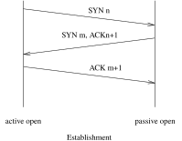
TCP setup handshake
Three segments are needed to exchange the information needed to make a new connection; The initiator, the client, sends a segment with the SYN flag set and its initial sequence number (ISN), $n$, is randomly generated; The receiver, the server, replies with another SYN segment containing its own ISN, $m$; It also ACKs the client’s ISN with $n+1$, the sequence number of the next byte it expects from the client; The initial SYN can be lost just like any other segment, so we need to ACK it independently of the first data byte, which comes later; The client ACKs the server’s ISN with $m+1$

23. TCP

Setup and Teardown
This is called a three way handshake
These segments contain no user data: they are overhead in setting up the connection
Overhead in time and overhead in packets on the network
After the handshake we can start sending data
The client (first one to initiate) is said to do an active open, while the server does a passive open

24. TCP

Setup and Teardown
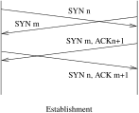
TCP simultaneous open
It is possible (but rare) for both hosts to do an active open, where the SYNs cross each other in flight
Matching TCP port numbers will identify when this happens
This is defined to produce one new connection, not two

25. TCP

Setup and Teardown
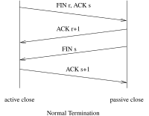
TCP teardown
Closing a connection takes up to four segments; TCP is full duplex, and a connection in one direction may be closed independently of the other; The FIN flag is set to indicate a half close: this indicates no more data will be sent from this end; We can still receive data at this end; The FIN is ACKed; When the other end wants to close, it sends a FIN and gets an appropriate ACK; Note there may still be data (and the corresponding returning ACKs) flowing from the server to the client before the server decides to close; The first close is called an active close; The other end does a passive close

26. TCP

Setup and Teardown
Active close from left
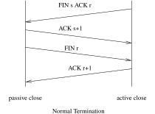
Active close from right
Either end can initiate the active close; it does not need to be the host that did the active open

27. TCP

Setup and Teardown
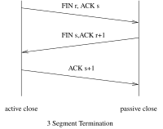
Three segment close
The passive close FIN can be piggybacked on the ACK: this then takes only three segments

28. TCP

Setup and Teardown
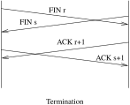
Simultaneous active close
There can (rarely) be a simultaneous active close: this takes four segments again

29. TCP

Termination
Connections are almost always ended by the FIN handshake, but there is another way to end a connection when something is badly wrong
This is to send a reset (RST) segment, i.e., with the RST flag set
This is for error cases, e.g., a segment arrives that doesn’t appear to be for a current connection, the server will reply with a RST
For example, if a server crashes and reboots while the client is still sending the server will not know what to do with the segments it is receiving; so it replies with a RST

30. TCP

Termination
When a host gets a RST it ends the connection immediately, discarding all state and buffered segments
Often seen by the application as a “connection reset by peer” message

31. TCP

Termination
A connection ended by FINs is called an orderly release; if ended by a RST it is an abortive release
RSTs are not ACKed: the connection ends right here
Exercise Think about the security aspects of this: a third party can inject a RST segment into a connection to kill it

