[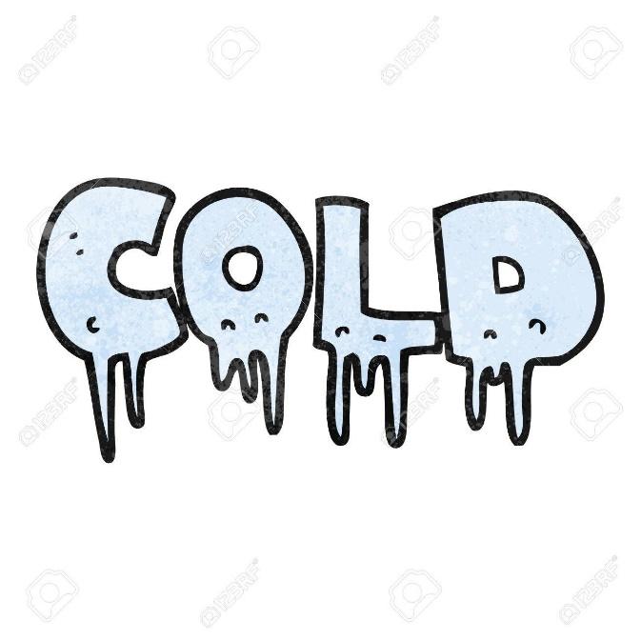](https://www.google.co.uk/url?sa=i&rct=j&q=&esrc=s&source=images&cd=&ved=2ahUKEwjql5q_3fXiAhVDyYUKHY6aCesQjRx6BAgBEAU&url=https%3A%2F%2Fwww.123rf.com%2Fphoto_53903528_stock-vector-freehand-textured-cartoon-word-cold.html&psig=AOvVaw2gOKc2dS7B6xRLHvc0pKof&ust=1561039884311312)*Science Quiz!!!*

Q1) What temperature does water freeze?......................................

Q2) What temperature does water boil?..........................................

Q3) What is the temperature of “*Absolute Zero*”?............................

Q4) What is the temperature on the surface of the Sun?.................

Q5) What is the temperature of the Sun’s core?...............................

[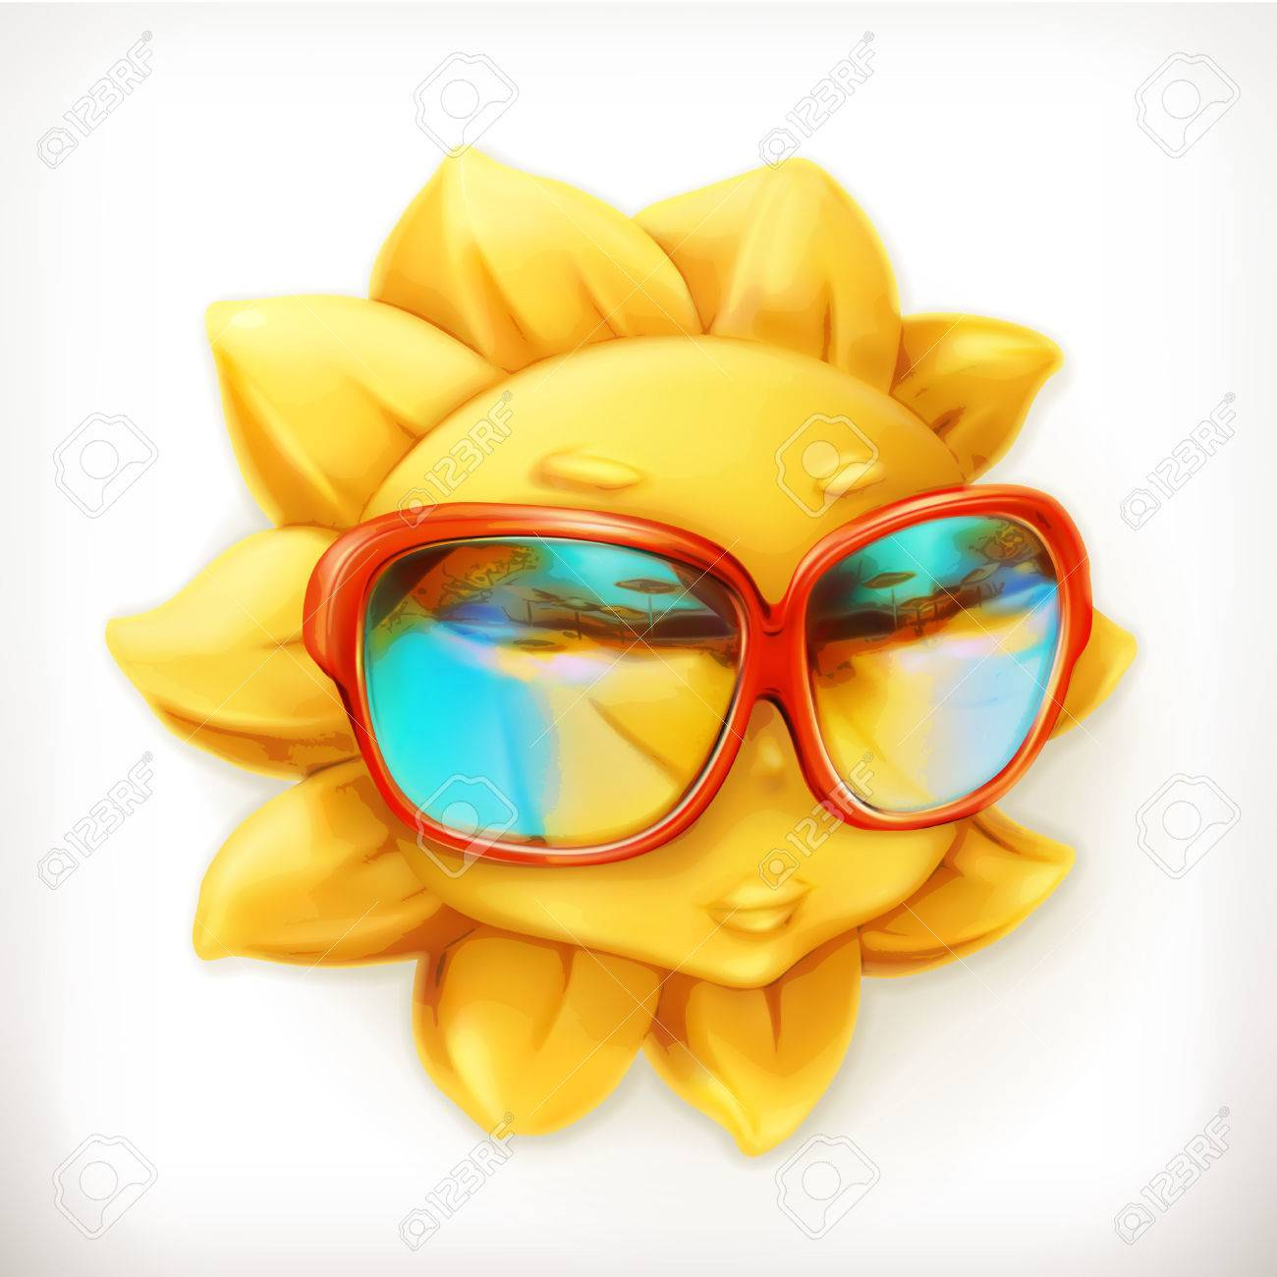](https://previews.123rf.com/images/natis76/natis761506/natis76150600053/41621678-hot-summer-sun-sunglasses-vector-icon.jpg)

Q6) What two elements make up water?..........................................

and …………………………………..

Q7) How many bonds do the following elements make?

* Oxygen makes ………………………..bonds
* Hydrogen makes ………………………………bond
* Carbon makes …………………………bonds

Q8) What temperature is liquid Nitrogen?.....................................

[](https://www.google.co.uk/url?sa=i&rct=j&q=&esrc=s&source=images&cd=&ved=2ahUKEwiS89Xk4_XiAhXExYUKHY5fC8YQjRx6BAgBEAU&url=https%3A%2F%2Fwww.canstockphoto.com%2Fillustration%2Fturn.html&psig=AOvVaw2lQCPeL35OJdNTBM8MWSTM&ust=1561041735699807)

Q9) How much of our air is Nitrogen gas?............................

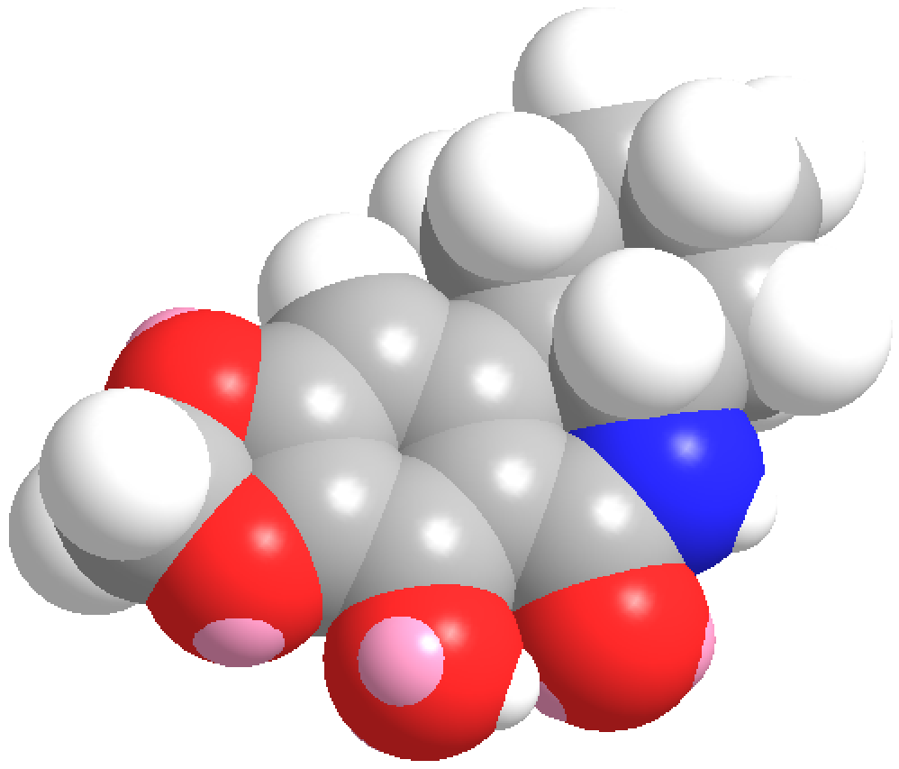

Q10) What are the states of matter?.................................................

…………………………………….……………………………………………………………….

………………………………………………………………………………………………………

Q11) How many elements are there?...................................................

Q12) When did the Big Bang happen?...................................................

Q13) Look at the following picture. Write down the colours in the spaces. **Magnesium** is also used in fireworks, but what colour does it produce?.........................................

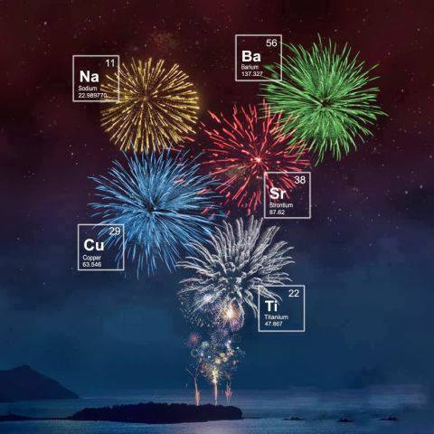

……….... …………

…………

………….

………….

*I hope you enjoyed your science talk!!!*